SE LAB GROUP ASSIGNMENT 1 REPORT
Software Engineering | Smart Ticketing System (Ticket Vendor Machine) | Sem 1_2627
Marking of this report
No. | Task | Marks | Section in this report
1 | Clarification Q&A (Excel) | 5 | 2.1
2 | Requirements Specification | 15 | 2.2
3 | Use Case Modeling | 10 | 3.1
4 | Activity Diagrams | 10 | 3.2
5 | Detailed System Modeling: "Buy a Ticket" | 15 | 3.3
6 | UI/UX Design | 5 | 4.1
7 | Architectural Design | 10 | 4.2, 4.3
8 | Visual Studio Engineering (Model-to-Code) | 10 | 5.1
9 | GitHub & AI Tooling (Copilot) | 10 | 5.2
10 | Demo Application (C# and MSSQL) | 10 | 5.3
Total |  | 100 | Weight: 20% of QT2 (plus 1 bonus point towards the Final Project for exceptional work)

Smart Ticketing System
Ticket Vendor Machine (TVM)
Software Engineering Lab Group Assignment 1 – Sem 1_2627
Group 69
1. 524H0158 : Nguyễn Gia Huy
2. 524H0041 : Trần Đỗ Quốc Anh
3. 524H0074 : Lê Anh Tuân
GitHub repository | Figma / other link | Date submitted
https://github.com/Narwhal1412/SE-QT2 | https://www.figma.com/make/cpd1VhfymogiWUdNunS68w/Create-a-New-App?t=ycoktueirSDFqjfx-1 | 31 October 2026

Table of Contents
Table of Contents 4
1. Introduction 6
1.1 Purpose and Scope 6
1.2 Problem Statement in Our Own Words 6
1.3 Team and Roles 6
2. Phase 1: Requirements Engineering (20 marks) 7
2.1 Clarification Q&A (5 marks) 7
2.2 Requirements Specification (15 marks) 11
2.2.1 Functional Requirements 11
2.2.2 Non-Functional Requirements 13
2.2.3 Domain Requirements 15
3. Phase 2: UML Modeling & System Design (35 marks) 17
3.1 Use Case Modeling (10 marks) 17
3.1.1 Use Case Diagram 17
3.1.2 Actors and Use Case List 17
3.1.3 Use Case Descriptions 18
3.2 Activity Diagrams (10 marks) 27
3.2.1 Passenger Buys a Ticket at the TVM 27
3.2.2 Communication with External Payment Gateways 28
3.3 Detailed System Modeling: Main Use Case "Buy a Ticket" (15 marks) 29
3.3.1 Sequence Diagram 29
3.3.2 State Chart Diagram 30
3.3.3 Class Diagram (Domain Model) 30
3.4 Model Consistency Check 31
4. Phase 3: UI/UX & Architecture (15 marks) 33
4.1 UI/UX Design (5 marks) 33
4.2 Architectural Design (10 marks) 46
4.2.1 Architecture Diagram 46
4.2.2 Deployment Diagram 48
5. Phase 4: Implementation, Tooling & Demo (30 marks) 50
5.1 Visual Studio Engineering: Model-to-Code (10 marks) 50
5.1.1 Forward Engineering (Model to Code) 50
5.1.2 Backward Engineering (Code to Model) 51
5.1.3 Code Map 55
5.2 GitHub & AI Tooling (10 marks) 56
5.2.1 Source Control 56
5.2.2 AI Assistance: Copilot Prompt Documentation 56
5.2.3 Reflection on AI Use 57
5.3 Demo Application (10 marks) 57
6. Checklist for "LabGroup_QT2_Assignment1.pdf" 61
7. Contribution of Each Member 62
8. Conclusion and Lessons Learnt 62
References 62
Appendix 63
Appendix A: readme.txt 63
Appendix B: Full-size Diagrams 63

1. Introduction

1.1 Purpose and Scope
This report documents the analysis, design and prototype of the Ticket Vendor Machine (TVM), the passenger kiosk of the Smart Ticketing System. It covers requirements engineering (clarification Q&A and functional, non-functional and domain requirements), UML modelling and system design, the user interface and architecture, the Visual Studio model-to-code work, the use of GitHub and Copilot, and a C# / MSSQL prototype of the main use case "Buy a Ticket". In scope: ticket purchase at the TVM with credit card, bank QR code or digital wallet, ticket printing, failure handling and refunds, TVM monitoring and servicing, fare management and daily reconciliation in the back-office. Out of scope: gate validation devices, cash payment, passes other than the single-journey ticket and the 1-day pass, and the passenger mobile app.

1.2 Problem Statement in Our Own Words
A transport operator wants ticket vendor machines at its MRT stations and bus stops. A passenger presses Start, chooses a destination and a payment mode, pays, and receives a paper ticket with a barcode. Three payment modes are mentioned: a credit card (inserted or tapped), a QR code linked to a bank, and a digital wallet where the TVM shows a QR code that the passenger scans with a phone. The statement is deliberately incomplete. It does not say which tickets and fares exist, in which order the payment mode is chosen, how long the machine waits, what happens when a card is declined, when the passenger cancels, when the printer or paper fails after the money was taken, when the network is down, how fast or how reliable the system must be, or how card and QR data is protected. We closed these gaps with 25 clarification questions and assumed answers (section 2.1) and turned the answers into 22 functional, 20 non-functional and 8 domain requirements (section 2.2). We assume a Vietnamese city network, so fares are in VND and the QR and wallet providers are VietQR, Momo, ZaloPay and VNPay.

1.3 Team and Roles
No. | Name | Student ID | Main responsibilities
1 | Trần Đỗ Quốc Anh | 524H0041 | Requirements Engineering (Clarification Q&A, Functional & Non-Functional Requirements), Use Case Modeling & Descriptions, State Chart Diagram.
2 | Nguyễn Gia Huy | 524H0158 | Team Lead, System Architecture (MVC & Deployment), Domain Model, C# .NET 10 WinForms Kiosk Prototype Implementation, MSSQL Database & Repository.
3 | Lê Anh Tuân | 524H0074 | UML Activity Diagrams (Passenger Purchase Flow & Payment Gateway Integration), Sequence Diagram, Model-to-Code Engineering & Code Map, Copilot Prompt Validation.

2. Phase 1: Requirements Engineering (20 marks)

2.1 Clarification Q&A (5 marks)
ID | Question to the stakeholder | Assumed answer | Why it matters | Requirement ID
Q01 | Which ticket types and transport modes does one TVM sell, and can it sell tickets for any origin? (to: Transport authority) | The TVM sells single-journey tickets and 1-day passes for MRT and bus. The origin is always the station or stop where the TVM is installed; the passenger chooses only the destination. | Fixes the scope of the destination menu and removes the need for an origin selection screen. | FR2, FR3
Q02 | How is the fare calculated, and in which currency and rounding? (to: Transport authority) | Fare comes from a fare table by origin and destination (zone / distance based), in whole VND rounded to the nearest 1,000 VND. The table is maintained centrally. | The fare must be shown before payment and must be identical on screen, payment request and ticket. | FR4, DR1, DR2
Q03 | Are there passenger categories (student, senior) and can one transaction buy several tickets? (to: Transport authority) | Fare categories are Adult, Student and Senior. One transaction can buy 1 to 5 tickets of the same type and destination. | Affects the selection screens, the total fare and the number of barcodes printed. | FR3, DR2
Q04 | What must be printed on the ticket, which barcode type is used, and how long is the ticket valid? (to: Operator) | Ticket shows ticket number, origin, destination, type, fare, date-time, expiry and TVM ID. Barcode is Code 128. A single-journey ticket is valid for one entry within 60 minutes on the day of issue. | Gates must be able to validate the ticket. The validity rule defines what happens to tickets that are not used. | FR10, DR3, DR4
Q05 | On which screen and in which order does the passenger select the payment mode? (to: Operator) | After the fare summary the TVM shows a payment-mode screen with three buttons (Credit Card, Bank QR, Digital Wallet); unavailable modes are hidden. | Defines the main flow order: Start, destination, fare, payment mode, payment, ticket. | FR1, FR5
Q06 | Which cards and entry methods are accepted, and when is a PIN needed? (to: Bank / payment gateway) | Visa, Mastercard, JCB and NAPAS credit and debit cards, by insert or tap. PIN is requested on a PIN pad when the processor asks for it (for example above the contactless limit). | Defines the card reader hardware, the PIN pad and the PCI scope. | FR6, DR5
Q07 | Are bank QR and wallet QR different payment methods, and how does the TVM learn that either was paid? (to: Bank / payment gateway) | Both are dynamic QR codes shown on the TVM. Bank QR follows VietQR and the bank notifies the server; the wallet QR is provider specific and the wallet notifies the server by callback. The TVM never reads the passenger's phone. | Two separate integrations with different confirmation messages; both must be modelled in the activity and sequence diagrams. | FR7, FR8, DR6, DR7
Q08 | Which wallet gateways must be supported at launch, and must more be added later? (to: Bank / payment gateway) | Momo, ZaloPay and VNPay at launch. The passenger chooses the wallet on screen. The payment service uses one common interface so a new gateway can be added without changing the TVM. | Leads to a payment-service layer and an adapter per gateway in the architecture and class diagram. | FR8, DR7
Q09 | Is the card authorised first and captured later, or charged at once? (to: Bank / payment gateway) | The card is authorised and captured in one step when the issuer approves. If the ticket cannot be printed, the payment is voided or refunded automatically. | Decides when the ticket may be printed and what must be reversed after a print failure. | FR9, FR15
Q10 | What happens if the card is declined, and how many attempts are allowed? (to: Bank / payment gateway) | A clear message is shown. The passenger has up to 3 attempts in total (same or other card) or can change payment mode; then the transaction is cancelled. | Adds a loop and failure paths to the activity diagram and a retry counter to the model. | FR14
Q11 | How long does the TVM wait at each step before giving up? (to: Operator) | Idle on a selection screen: 60 s. Card prompt: 30 s. QR payment: 120 s. After a timeout the TVM offers "Try again" or "Cancel". | Timeouts create states and transitions in the state chart and exception flows in the use cases. | FR12, FR13
Q12 | What should happen to a payment that is confirmed after the transaction timed out or was cancelled? (to: Bank / payment gateway) | No ticket is printed. The late payment is automatically refunded, and every payment request has a unique transaction ID so the same payment can never be applied twice. | Hidden complexity: asynchronous callbacks and duplicate prevention drive the sequence diagram and the data model. | FR16, NFR2
Q13 | When can the passenger cancel and what happens afterwards? (to: Operator) | Cancel is available on every screen until payment is confirmed; it voids pending QR sessions and returns to Idle. After payment is confirmed the ticket is printed and cannot be cancelled at the TVM. | Defines the Cancel use case and the point of no return in the state chart. | FR11
Q14 | What happens if payment is confirmed but the ticket cannot be printed, and how fast must the refund start? (to: Operator) | The refund is started automatically within 60 seconds in 99% of cases. The screen shows a reference number; money returns to the card, bank or wallet account by the provider's normal settlement time. | This is the main money-safety risk and the main reliability requirement. | FR15, NFR2, NFR1
Q15 | What should the TVM do when paper is low, paper is out, or the printer jams? (to: Maintenance) | Alert maintenance when fewer than 50 tickets remain. Paper out or jam stops sales and shows "Out of service"; a jam during a paid sale triggers the automatic refund. | Adds device monitoring, alerts and an Out of service state. | FR18, FR19
Q16 | Which devices does the TVM have, and does it accept cash? (to: Maintenance) | Touchscreen, EMV contact and contactless reader with PIN pad, thermal ticket printer, network module and a door contact. No cash acceptance and no change handling. | Removes cash use cases and defines the hardware nodes for the deployment diagram. | FR6, NFR19
Q17 | What response times are acceptable for each step, and for the whole purchase? (to: Operator) | Menu <= 1 s, fare screen <= 1 s, card result <= 5 s, QR shown <= 2 s, wallet confirmation on screen <= 2 s, print start <= 2 s, whole system time per purchase <= 15 s (all at the 95th percentile). | Gives each step a measurable limit that can be tested in the demo and the log. | NFR7, NFR8, NFR9, NFR10, NFR11, NFR12, NFR13, NFR14
Q18 | What availability and failure rate does the operator expect? (to: Operator) | Each TVM is available 99.5% of the operating hours (05:00-23:00); the central server 99.9%; at least 99.5% of paid sales print a ticket without staff help. | Gives measurable reliability targets for the TVM and the server. | NFR5, NFR6, NFR1
Q19 | How many TVMs will be connected and what is the peak transaction rate? (to: Transport authority) | 500 TVMs; at peak, 100 transactions per second across the central system (each TVM sells about 1 ticket every 30 s at peak). | Sizes the central server and the load test. | NFR20
Q20 | What should the TVM do if the network or the central server is not reachable, and after a power cut? (to: Operator) | Card, QR and wallet need a live connection, so the TVM disables them within 10 s and shows Out of service for payment. It buffers up to 10,000 log records and syncs within 5 minutes after reconnection. After a power cut it returns to Idle within 90 s and recovers any open transaction. | Hidden complexity: no offline sales, but the log and the open transaction must survive. | NFR4, NFR3, FR19
Q21 | Who is responsible for card data and which security standard applies? (to: Bank / payment gateway) | Card data goes only through a PCI-certified encrypting reader. The TVM software never sees, stores or logs the card number or PIN. | Keeps the application out of the most demanding part of PCI scope. | NFR15, DR5
Q22 | How are QR codes and gateway confirmations protected against fraud or replay? (to: Bank / payment gateway) | Each QR is single-use and expires after 120 s. All traffic uses TLS 1.2+, and every callback must carry a valid signature or it is ignored. | Defines the signature check in the payment service and the security tests. | NFR17, NFR16
Q23 | Which languages and accessibility features must the screens support? (to: Passenger) | Vietnamese and English; large text (>= 18 pt), high contrast (>= 4.5:1), touch targets >= 15 mm, and a purchase in no more than 5 touches. | Drives the wireframes and the usability test. | FR1, NFR18, NFR19
Q24 | Who maintains the machines and fares, and how do they sign in? (to: Maintenance) | Maintenance staff use a staff card and PIN on the TVM service menu (refill, self-test, reset). An administrator maintains fares and destinations in the back-office and changes reach all online TVMs within 5 minutes. | Adds two more actors and use cases (Service the TVM, Manage fares). | FR21, FR20, FR18
Q25 | Which records must be kept, how are they checked, and for how long? (to: Transport authority) | Every transaction step is logged and synchronised; each day the back-office reconciles with provider settlement files. Records are kept for 5 years (to be confirmed by Finance and Legal) and handled under Decree 13/2023/ND-CP. | Adds the reconciliation use case and the retention and privacy rule. | FR17, FR22, DR8
Hidden complexities we uncovered
1. Money safety is the biggest risk. The statement stops at "the ticket is issued", but payment is confirmed by an outside party before printing, so the printer can fail after the money is taken (Q09, Q14). This led to the automatic refund requirement and to a "paid, not printed" outcome in the use cases and the state chart.
2. QR and wallet payments are asynchronous. The passenger pays on a phone and the gateway answers later by callback, so the answer can arrive late, twice, or forged (Q07, Q12, Q22). We added unique transaction IDs, QR expiry, signature checks and a late-payment refund.
3. Time limits were missing. Without timeouts for idle, card and QR waiting the machine could block for ever (Q11). The values 60 s, 30 s and 120 s create the timeout transitions in the activity and state diagrams.
4. The machine can lose its network or power during a sale (Q20). We chose no offline sales, with fast detection, a local log buffer and recovery of the open transaction after a restart.
5. "Reliability" and "response time" had no numbers (Q17, Q18). We defined availability (99.5% per TVM, 99.9% server), print success (99.5%), and response limits per step with percentiles, so each one can be tested in the demo and in the log.

2.2 Requirements Specification (15 marks)

2.2.1 Functional Requirements
ID | Requirement ("The system shall…") | Priority | Use case | Source (Q&A)
FR1 | The TVM shall display a welcome screen with a "Start" button and a language selector (Vietnamese / English) whenever it is idle. | High | UC01 | Q05, Q23
FR2 | After the passenger presses "Start", the TVM shall display a menu of destinations (stations and bus stops), grouped by line / mode (MRT, Bus) and searchable by name. | High | UC02 | Q01
FR3 | The TVM shall let the passenger choose the ticket type (single journey or 1-day pass), the fare category (Adult, Student, Senior) and the quantity (1 to 5 tickets per transaction). | Medium | UC02 | Q01, Q03
FR4 | The TVM shall calculate the total fare in VND from the current fare table (origin = this TVM's station, destination = selected) and show it to the passenger before payment is requested. | High | UC02 | Q02
FR5 | The TVM shall present a payment-mode screen offering Credit Card, Bank QR Code and Digital Wallet, and shall show only the modes that are currently available. | High | UC01 | Q05
FR6 | For card payment, the TVM shall prompt the passenger to insert or tap a credit / debit card, request authorisation from the card processor, and ask for a PIN on the secure PIN pad when the processor requires it. | High | UC03 | Q06, Q16
FR7 | For Bank QR payment, the TVM shall generate a dynamic bank QR code (amount and transaction reference embedded), display it on screen and wait for the bank's payment confirmation. | High | UC04 | Q07
FR8 | For Digital Wallet payment, the TVM shall let the passenger pick a wallet (Momo, ZaloPay or VNPay), generate and display that wallet's QR code, and wait for the wallet gateway's payment confirmation. | High | UC05 | Q07, Q08
FR9 | The TVM shall issue a ticket only after the payment processor has returned a confirmed (approved / paid) status for the transaction. | High | UC01, UC06 | Q09
FR10 | The TVM shall print a paper ticket carrying a barcode, ticket number, origin, destination, ticket type, fare, issue date-time, expiry and TVM ID, and then show a success screen with the transaction reference. | High | UC06 | Q04
FR11 | The TVM shall provide a "Cancel" button on every screen before payment is confirmed; cancelling shall void any pending payment session (including displayed QR codes) and return the TVM to Idle. | High | UC07 | Q13
FR12 | The TVM shall discard the current selection and return to the welcome screen after 60 seconds without passenger input before a payment has been started. | Medium | UC01 | Q11
FR13 | The TVM shall expire a pending card prompt after 30 seconds and a pending QR payment after 120 seconds, tell the passenger, and offer "Try again" or "Cancel". | High | UC03, UC04, UC05 | Q11
FR14 | If a card payment is declined, the TVM shall show a clear message and allow up to 3 attempts in total (same or another card) or a change of payment mode before cancelling the transaction. | High | UC03 | Q10
FR15 | If a payment is confirmed but the ticket cannot be printed (printer jam, paper out, power fault), the TVM / server shall automatically start a refund or void of that payment and show the passenger a reference number. | High | UC08 | Q09, Q14
FR16 | The system shall give every payment request a unique transaction ID (idempotency key) so that a payment is never charged twice, and shall automatically refund any payment that is confirmed after the transaction has timed out or been cancelled. | High | UC08 | Q12
FR17 | The TVM shall record every transaction step (transaction ID, TVM ID, timestamp, state, result) in a local store and synchronise it to the central database. | High | UC01, UC12 | Q25
FR18 | The TVM shall send a heartbeat with its status (network, printer, paper level, card reader, door contact) to the monitoring server every 60 seconds and raise an alert when paper falls below 50 tickets or a device fails. | High | UC10 | Q15, Q24
FR19 | The TVM shall stop selling and show an "Out of service" screen when the printer or paper is unavailable, and shall disable only the affected payment mode when a single payment channel is unavailable. | High | UC10 | Q15, Q20
FR20 | The back-office shall let an authorised administrator maintain destinations, ticket types and fares, and shall distribute approved changes to all online TVMs within 5 minutes without a software redeploy. | Medium | UC11 | Q24
FR21 | The TVM shall provide an authenticated service menu (staff card and PIN) for maintenance staff to record a paper refill, run a hardware self-test and reset fault flags. | Medium | UC09 | Q24
FR22 | The back-office shall reconcile TVM transactions with the settlement files of the card processor, bank and wallet gateways once per day and flag every mismatch for review. | Medium | UC12 | Q25

2.2.2 Non-Functional Requirements
ID | Category | Measurable requirement | Measurement method | Related FR
NFR1 | Reliability | At least 99.5% of transactions with confirmed payment shall end with a readable ticket printed without staff intervention; all others shall end in an automatic refund (see the refund requirement). | Monthly analysis of transaction log (paid vs. printed) and printer error log | FR10, FR15
NFR2 | Reliability | No customer shall be charged without receiving a ticket or a refund: 100% of confirmed payments shall end as a printed ticket or an initiated refund, and the refund request shall be submitted within 60 seconds of the failure in 99% of cases. | Daily reconciliation report; fault-injection test (paper out, jam, power cut) repeated 100 times | FR15, FR16
NFR3 | Reliability | After a power loss or software crash the TVM shall restart to the Idle screen within 90 seconds and shall recover any in-flight transaction from local storage without a duplicate charge. | Forced power-cut test on a test TVM (50 repetitions) with log inspection | FR17, FR16
NFR4 | Reliability | When the central server or payment network cannot be reached, the TVM shall detect it within 10 seconds, disable the card, QR and wallet options, and keep up to 10,000 log records locally to synchronise within 5 minutes after the connection returns. | Network-cut test (disconnect, wait, reconnect) with timestamps from the TVM log | FR19, FR17, FR18
NFR5 | Availability | Each TVM shall be available for sale for at least 99.5% of its operating hours (05:00 to 23:00 daily) in every calendar month, excluding planned maintenance. | Heartbeat records from the monitoring server (up time / scheduled time) | FR18, FR19
NFR6 | Availability | The central ticketing server (payment service, database, back-office) shall be available at least 99.9% of the time in every calendar month. | Uptime monitoring probe every 30 s on the payment-service endpoint | FR18, FR17
NFR7 | Response time | The TVM shall display the destination menu within 1.0 second of the Start button being pressed in 95% of cases, and within 2.0 seconds in 99% of cases. | Timestamps in the TVM log over 1,000 transactions | FR2
NFR8 | Response time | The TVM shall give visible feedback to every touch within 200 milliseconds in 99% of touches. | High-speed camera / UI event timestamps over 500 touches | FR1, FR2
NFR9 | Response time | After a destination is selected, the TVM shall display the fare summary and payment-mode screen within 1.0 second in 95% of cases. | Timestamps in the TVM log over 1,000 transactions | FR4, FR5
NFR10 | Response time | The TVM shall show the card result (approved or declined) within 5 seconds of the card being tapped or inserted in 95% of cases, and shall treat no answer within 10 seconds as a timeout. | Timestamps (card read, authorisation response) over 1,000 card payments in the test environment | FR6
NFR11 | Response time | The TVM shall display the QR code within 2.0 seconds of the passenger selecting Bank QR or a wallet in 95% of cases, and within 4.0 seconds in 99% of cases. | Timestamps (selection, QR rendered) over 1,000 QR requests against the gateway sandbox | FR7, FR8
NFR12 | Response time | After the server receives a payment confirmation from a gateway, the TVM shall show "Payment received" within 2 seconds in 95% of cases. | Server and TVM timestamps over 1,000 sandbox payments | FR8, FR7, FR9
NFR13 | Response time | The TVM shall start printing within 2 seconds of payment confirmation and eject the finished ticket within 5 seconds of confirmation in 99% of cases. | Timestamps (confirmation, print start, eject sensor) over 1,000 tickets | FR10, FR9
NFR14 | Response time | The processing time caused by the system for one complete card purchase (Start pressed to ticket ejected, excluding the passenger's own decision and card handling time) shall not exceed 15 seconds in 95% of cases. | Sum of step timestamps in the TVM log over 1,000 card transactions | FR1, FR2, FR4, FR5, FR6, FR9, FR10
NFR15 | Security | The TVM shall never store, display or log the full card number, expiry date or PIN; card data shall pass only through a PCI-certified reader that encrypts it at the point of entry. | PCI DSS assessment, log and database inspection, penetration test | FR6
NFR16 | Security | All communication between TVM, server and gateways shall use TLS 1.2 or higher, and every gateway callback shall be rejected unless its signature (HMAC-SHA256 or the provider's scheme) is valid. | Security test suite with 200 forged and replayed callbacks; TLS configuration scan | FR7, FR8, FR9
NFR17 | Security | Each QR code shall be bound to one transaction, be single-use and expire after 120 seconds; a replayed or expired QR shall never produce a ticket. | Test with 100 replayed and 100 expired QR payments against the sandbox | FR7, FR8, FR16
NFR18 | Usability | A first-time passenger shall be able to buy a ticket with no more than 5 touches (excluding card or phone handling), and at least 90% of 20 test users shall succeed within 90 seconds without help. | Usability test with 20 users, observation sheet and stopwatch | FR2, FR3, FR5
NFR19 | Usability | All screens shall be available in Vietnamese and English, use text of at least 18 pt with a contrast ratio of at least 4.5:1, and have touch targets of at least 15 mm. | Design review against the checklist and measurement on a real screen | FR1, FR2
NFR20 | Capacity | The central system shall support 500 TVMs and a peak of 100 transactions per second while keeping all response-time requirements above. | Load test (JMeter or similar) for 30 minutes at peak load | FR17, FR9

2.2.3 Domain Requirements
ID | Domain requirement | Domain / source | Related FR / NFR
DR1 | All fares shall be in Vietnamese dong (VND) as whole numbers, rounded to the nearest 1,000 VND, with the same fare shown on screen, ticket and payment request. | Transport authority fare policy; VND | FR4, FR10
DR2 | The fare shall be taken from the transport authority's fare table by origin and destination (zone or distance based), with a discount for Student and Senior categories and a lower price for the 1-day pass, as defined by the authority. | Transport authority fare policy | FR4, FR3
DR3 | A single-journey ticket shall be valid for one entry within 60 minutes of issue on the day of issue; a 1-day pass shall be valid for unlimited entry until the end of service on the day of issue. | Operator ticketing rules | FR10
DR4 | The barcode shall be Code 128 encoding a unique, non-sequential ticket number plus a verification code, so that gates can validate the ticket against the central database or by signature when offline. | Operator gate system; Code 128 (ISO/IEC 15417) | FR10
DR5 | Card acceptance shall follow EMV contact and contactless rules, and the TVM and its payment flow shall comply with PCI DSS and PCI PTS for the PIN pad. | EMVCo; PCI SSC (PCI DSS, PCI PTS) | FR6, NFR15
DR6 | Bank QR codes shall follow the VietQR (NAPAS) standard so that any participating banking app can pay them. | NAPAS VietQR standard | FR7
DR7 | Wallet payments shall follow each provider's merchant API contract (Momo, ZaloPay, VNPay): signed requests, server-to-server confirmation (callback / IPN), and daily settlement files. | Momo, ZaloPay and VNPay merchant API contracts | FR8, NFR16
DR8 | Personal and transaction data shall be handled according to Vietnamese personal-data protection rules (Decree 13/2023/ND-CP), and transaction and audit records shall be kept for 5 years (period to be confirmed by the operator's Finance and Legal teams). | Decree 13/2023/ND-CP; accounting record rules (to be confirmed) | FR17, FR22

3. Phase 2: UML Modeling & System Design (35 marks)

3.1 Use Case Modeling (10 marks)

3.1.1 Use Case Diagram
[ Use case diagram ]
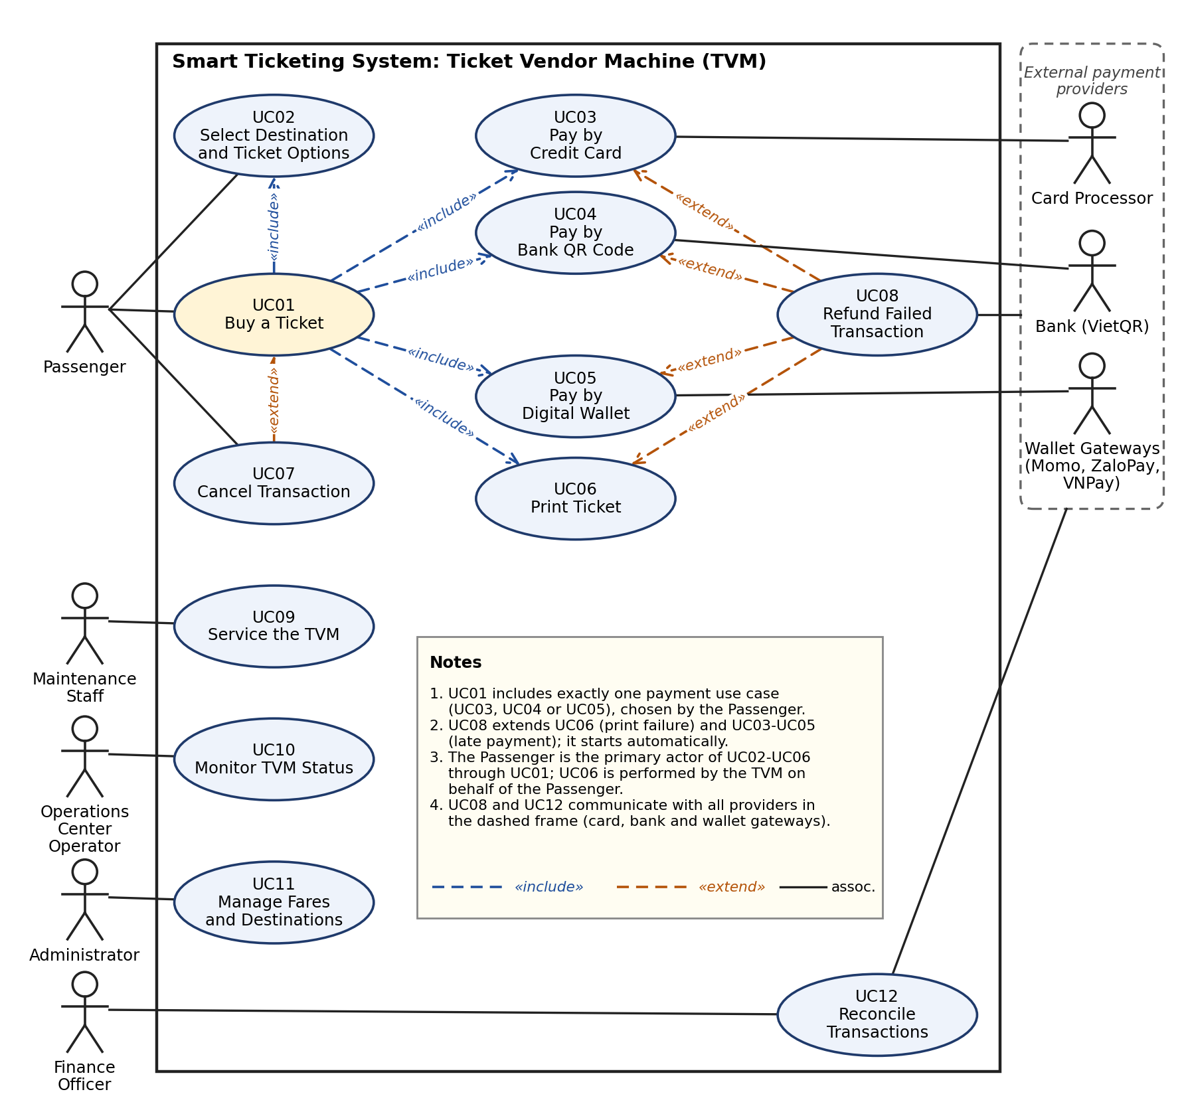

3.1.2 Actors and Use Case List
ID | Use case | Primary actor | Short description
UC01 | Buy a Ticket | Passenger | Main use case: from pressing Start to receiving the ticket. Includes UC02, one of UC03/UC04/UC05 for payment, and UC06.
UC02 | Select Destination and Ticket Options | Passenger | Choose destination, ticket type, fare category and quantity and see the fare.
UC03 | Pay by Credit Card | Passenger | Insert or tap a card, authorise the payment and receive the result.
UC04 | Pay by Bank QR Code | Passenger | Scan the dynamic VietQR code with a banking app and receive confirmation.
UC05 | Pay by Digital Wallet | Passenger | Choose a wallet, scan its QR code and receive confirmation.
UC06 | Print Ticket | TVM (on behalf of Passenger) | After confirmed payment, print the paper ticket with barcode and show the success screen.
UC07 | Cancel Transaction | Passenger | Cancel before payment is confirmed and return to Idle (extends UC01).
UC08 | Refund Failed Transaction | Payment system (automatic) | Refund or void a confirmed payment when no ticket was issued, or when payment arrives late.
UC09 | Service the TVM | Maintenance Staff | Sign in to the service menu, refill paper, run self-test and reset faults.
UC10 | Monitor TVM Status | Operations Center Operator | Receive heartbeats and alerts and see which TVMs or payment channels are unavailable.
UC11 | Manage Fares and Destinations | Administrator | Maintain destinations, ticket types and fares and distribute them to the TVMs.
UC12 | Reconcile Transactions | Finance Officer | Compare TVM transactions with provider settlement files and review mismatches.
Relationships to show in the use case diagram: UC01 <<include>> UC02 and UC06; UC01 includes exactly one payment use case, UC03, UC04 or UC05 (the passenger's choice); UC07 <<extend>> UC01 (before payment is confirmed); UC08 <<extend>> UC06 and UC03-UC05 (print failure or late payment). Actors: Passenger, Maintenance Staff, Operations Center Operator, Administrator, Finance Officer (primary) and Card Processor, Bank (VietQR), Wallet Gateways (Momo, ZaloPay, VNPay) (secondary).

3.1.3 Use Case Descriptions
UC01: Buy a Ticket
Item | Content
Use case ID and name | UC01 Buy a Ticket
Primary actor / secondary actors | Primary: Passenger  Secondary: Payment gateways (via UC03-UC05)
Related requirements | FR: FR1, FR5, FR9, FR12, FR17  NFR: NFR3, NFR7, NFR8, NFR14, NFR18, NFR19, NFR20
Pre-conditions | The TVM is in the Idle state and is in service.  At least one payment mode is available.  The TVM is online with the central server.
Trigger | The passenger presses the "Start" button on the welcome screen.
Main flow | 1. Passenger presses "Start". TVM opens a transaction with a unique transaction ID.  2. TVM shows the destination menu. [include UC02 Select Destination and Ticket Options]  3. TVM shows the fare summary and the payment-mode screen.  4. Passenger selects a payment mode (Credit Card, Bank QR or Digital Wallet).  5. TVM starts the matching payment use case. [include UC03, UC04 or UC05]  6. Payment is confirmed. TVM stores the result and moves to the Printing state.  7. TVM prints the ticket and shows the success screen. [include UC06]  8. TVM records the transaction and returns to Idle.
Alternate flows | A1 (step 4): The passenger goes back to change the destination or ticket options; the TVM returns to step 2 and recalculates the fare.  A2 (step 4): Only some payment modes are available; the TVM shows only those modes.
Exception flows | E1: 60 s without input before payment: transaction discarded, TVM returns to Idle.  E2: Passenger cancels before payment is confirmed: UC07 Cancel Transaction runs.  E3: Payment fails or times out: see UC03, UC04, UC05; the passenger may retry or cancel.  E4: Printing fails after payment: UC08 Refund Failed Transaction runs and the TVM goes Out of service.  E5: Power loss during the transaction: on restart the TVM recovers the open transaction and refunds if it was paid.
Post-conditions | A ticket is printed and the payment is confirmed, OR no money is taken (cancelled / failed), OR a refund has been started.  The transaction is logged with its final result.  The TVM is Idle (or Out of service after a device fault).
UC02: Select Destination and Ticket Options
Item | Content
Use case ID and name | UC02 Select Destination and Ticket Options
Primary actor / secondary actors | Primary: Passenger  Secondary: None
Related requirements | FR: FR2, FR3, FR4  NFR: NFR9  DR: DR1, DR2
Pre-conditions | A transaction has been started (UC01 step 1).  The fare table is loaded on the TVM.
Trigger | UC01 reaches the destination selection step.
Main flow | 1. TVM shows destinations grouped by MRT line and bus route, with a search box.  2. Passenger selects a destination.  3. TVM shows ticket type (single journey or 1-day pass), fare category (Adult, Student, Senior) and quantity (1 to 5).  4. Passenger confirms the options.  5. TVM calculates the total fare in VND from the fare table and shows the fare summary.
Alternate flows | A1: Passenger uses the search box to find a destination by name.  A2: Passenger changes quantity or category; the fare is recalculated at once.
Exception flows | E1: No fare exists for the selected origin and destination: TVM shows an error and asks for another destination.  E2: Fare table is missing or out of date: TVM goes Out of service and alerts the operator (UC10).
Post-conditions | Destination, ticket type, category, quantity and fare are stored in the open transaction.
UC03: Pay by Credit Card
Item | Content
Use case ID and name | UC03 Pay by Credit Card
Primary actor / secondary actors | Primary: Passenger  Secondary: Card processor
Related requirements | FR: FR6, FR13, FR14  NFR: NFR10, NFR15  DR: DR5
Pre-conditions | The passenger has chosen Credit Card on the payment-mode screen.  The card reader and the card processor are available.
Trigger | UC01 starts card payment.
Main flow | 1. TVM shows the amount and asks the passenger to insert or tap the card; a 30 s timer starts.  2. Passenger inserts or taps the card.  3. Card reader encrypts the card data and sends it to the card processor with the amount and transaction ID.  4. If required, TVM asks for the PIN on the PIN pad.  5. Card processor authorises the payment and returns "approved".  6. TVM marks the payment as confirmed and returns control to UC01.
Alternate flows | A1 (step 4): No PIN is needed for a contactless payment below the limit; the step is skipped.
Exception flows | E1: Card declined: TVM shows the message, increases the attempt counter and offers another card or another payment mode (maximum 3 attempts, then the transaction is cancelled).  E2: No card within 30 s: timeout, TVM offers "Try again" or "Cancel".  E3: No answer from the processor within 10 s: timeout; TVM voids any pending authorisation and informs the passenger.  E4: Card reader fault: TVM disables the card mode and offers QR or wallet.
Post-conditions | Payment is confirmed and the processor reference is stored; OR the payment is not confirmed and no money has been taken.
UC04: Pay by Bank QR Code
Item | Content
Use case ID and name | UC04 Pay by Bank QR Code
Primary actor / secondary actors | Primary: Passenger  Secondary: Bank (VietQR)
Related requirements | FR: FR7, FR13  NFR: NFR11, NFR16, NFR17  DR: DR6
Pre-conditions | The passenger has chosen Bank QR on the payment-mode screen.  The bank (VietQR) service is available.
Trigger | UC01 starts Bank QR payment.
Main flow | 1. TVM requests a dynamic VietQR code from the payment service for the amount and transaction ID.  2. Payment service returns the QR payload; TVM displays the QR code and a 120 s countdown.  3. Passenger scans the QR code with a banking app and approves the payment.  4. Bank sends the confirmation to the payment service.  5. Payment service checks the signature and the amount and notifies the TVM.  6. TVM shows "Payment received" and returns control to UC01.
Alternate flows | A1: Passenger presses "Show new QR" before expiry; the old QR is voided and a new one is created.
Exception flows | E1: QR not paid within 120 s: QR expires, TVM offers "Try again" or "Cancel".  E2: Callback signature or amount is invalid: payment service ignores it, logs a security event and the TVM keeps waiting until expiry.  E3: Payment arrives after expiry or cancellation: no ticket; UC08 refunds it automatically.  E4: QR cannot be generated within 4 s: TVM shows an error and offers other payment modes.
Post-conditions | Payment is confirmed and the bank reference is stored; OR the QR is voided and no ticket is issued.
UC05: Pay by Digital Wallet
Item | Content
Use case ID and name | UC05 Pay by Digital Wallet
Primary actor / secondary actors | Primary: Passenger  Secondary: Wallet gateway (Momo, ZaloPay, VNPay)
Related requirements | FR: FR8, FR13  NFR: NFR11, NFR12, NFR16, NFR17  DR: DR7
Pre-conditions | The passenger has chosen Digital Wallet on the payment-mode screen.  At least one wallet gateway is available.
Trigger | UC01 starts wallet payment.
Main flow | 1. TVM shows the available wallets (Momo, ZaloPay, VNPay).  2. Passenger selects a wallet.  3. TVM asks the payment service for a wallet QR code for the amount and transaction ID.  4. Payment service sends a signed request to the selected gateway and returns the QR payload.  5. TVM displays the QR code with a 120 s countdown.  6. Passenger scans the QR code with the wallet app and confirms.  7. Gateway sends a signed callback (IPN) to the payment service.  8. Payment service verifies the signature, amount and transaction ID and notifies the TVM.  9. TVM shows "Payment received" and returns control to UC01.
Alternate flows | A1: Passenger goes back and selects another wallet; the first QR is voided.
Exception flows | E1: QR not paid within 120 s: QR expires, TVM offers "Try again" or "Cancel".  E2: Gateway does not answer: TVM hides that wallet and offers the others (UC10 is alerted).  E3: Callback with an invalid signature: ignored and logged.  E4: Payment confirmed after expiry or cancellation: UC08 refunds it automatically.
Post-conditions | Payment is confirmed and the gateway reference is stored; OR the QR is voided and no ticket is issued.
UC06: Print Ticket
Item | Content
Use case ID and name | UC06 Print Ticket
Primary actor / secondary actors | Primary: TVM (on behalf of Passenger)  Secondary: Ticket printer
Related requirements | FR: FR9, FR10  NFR: NFR1, NFR13  DR: DR3, DR4
Pre-conditions | Payment for the transaction is confirmed.  Printer and paper are available.
Trigger | UC01 receives the confirmed payment.
Main flow | 1. TVM creates a unique ticket number and the barcode (Code 128) for each ticket.  2. TVM sends the ticket layout to the printer within 2 s of confirmation.  3. Printer prints the ticket with barcode and cuts it.  4. Printer sensor reports that the ticket was ejected.  5. TVM shows the success screen with the transaction reference and the ticket details.  6. TVM saves the ticket records and the transaction result.
Alternate flows | A1: Several tickets (quantity > 1) are printed one after another; the success screen shows when all are ejected.
Exception flows | E1: Printer jam, paper out or print error: TVM stops, marks the transaction as "paid, not printed", starts UC08 and goes Out of service.  E2: Printer reports success but the ticket is not taken: ticket stays in the tray; the transaction is still complete.  E3: Paper low (fewer than 50 tickets): sale continues, an alert goes to UC10.
Post-conditions | The ticket exists and is stored with its number, validity and fare; OR a refund has been started.
UC07: Cancel Transaction
Item | Content
Use case ID and name | UC07 Cancel Transaction
Primary actor / secondary actors | Primary: Passenger  Secondary: None
Related requirements | FR: FR11
Pre-conditions | A transaction is open and payment has not been confirmed.
Trigger | The passenger presses "Cancel" on any screen.
Main flow | 1. Passenger presses "Cancel".  2. TVM asks for a short confirmation.  3. Passenger confirms.  4. TVM voids any pending card or QR session through the payment service.  5. TVM records the transaction as cancelled and returns to Idle.
Alternate flows | A1: Passenger answers "No" to the confirmation; the TVM returns to the previous screen.
Exception flows | E1: Payment is confirmed while the cancel is in progress: the cancel is rejected and the ticket is printed (UC06).
Post-conditions | No money is taken; the transaction is stored as cancelled; the TVM is Idle.
UC08: Refund Failed Transaction
Item | Content
Use case ID and name | UC08 Refund Failed Transaction
Primary actor / secondary actors | Primary: Payment system (automatic)  Secondary: Payment gateways
Related requirements | FR: FR15, FR16  NFR: NFR2
Pre-conditions | A payment was confirmed for a transaction that has no printed ticket, OR a payment was confirmed after the transaction expired or was cancelled.
Trigger | Print failure, or a late or duplicate payment confirmation.
Main flow | 1. Payment system detects the case and marks the transaction "refund required".  2. Payment system sends a refund or void request to the gateway with the original reference and the same transaction ID.  3. Gateway accepts the request and returns a refund reference.  4. TVM (if still involved) shows the reference number to the passenger.  5. Payment system stores the refund result in the log.
Alternate flows | A1: The gateway supports voiding: the payment is voided instead of refunded.
Exception flows | E1: Gateway does not answer: the request is retried (up to 5 times at growing intervals) and the case stays in the review list of UC12.  E2: Refund is refused: an alert is sent to the Finance Officer for manual handling.
Post-conditions | A refund or void has been requested for 100% of the affected payments; the case is traceable by reference number.
UC09: Service the TVM
Item | Content
Use case ID and name | UC09 Service the TVM
Primary actor / secondary actors | Primary: Maintenance Staff  Secondary: None
Related requirements | FR: FR21
Pre-conditions | The maintenance staff member has a valid staff card and PIN.  The TVM door is opened with a key.
Trigger | Maintenance staff open the service menu (after an alert or on a routine visit).
Main flow | 1. Staff member taps the staff card and enters the PIN.  2. TVM authenticates the staff member and shows the service menu.  3. Staff member refills paper and records the new paper count.  4. Staff member runs the hardware self-test (screen, reader, printer, network).  5. Staff member resets the fault flags and exits the menu.  6. TVM sends a status update and returns to Idle if all tests pass.
Alternate flows | A1: Only a self-test is run without a refill.
Exception flows | E1: Wrong PIN 3 times: staff card is blocked and the event is logged.  E2: Self-test fails: TVM stays Out of service and tells the operator which device failed.
Post-conditions | Paper level, test result and staff ID are logged; TVM is in service or still Out of service.
UC10: Monitor TVM Status
Item | Content
Use case ID and name | UC10 Monitor TVM Status
Primary actor / secondary actors | Primary: Operations Center Operator  Secondary: None
Related requirements | FR: FR18, FR19  NFR: NFR4, NFR5, NFR6
Pre-conditions | TVMs send heartbeats to the monitoring server.
Trigger | A heartbeat is missing for 3 minutes, or a TVM reports a device or paper alert.
Main flow | 1. Monitoring server receives the heartbeats and the alerts.  2. Server updates the status board (in service, payment mode down, out of service).  3. Operator sees the alert and its details.  4. Operator sends a maintenance request to staff (UC09).  5. Server shows the TVM as in service again after a successful heartbeat.
Alternate flows | A1: A payment gateway is down: the server tells all TVMs to hide that mode.
Exception flows | E1: The monitoring server itself is down: TVMs keep selling and buffer their logs (see the offline requirement).
Post-conditions | The status of every TVM is current and each alert is assigned or closed.
UC11: Manage Fares and Destinations
Item | Content
Use case ID and name | UC11 Manage Fares and Destinations
Primary actor / secondary actors | Primary: Administrator  Secondary: None
Related requirements | FR: FR20
Pre-conditions | The administrator is signed in to the back-office with the right role.
Trigger | The authority approves a change to fares, destinations or ticket types.
Main flow | 1. Administrator opens the fare management page.  2. Administrator adds or edits destinations, ticket types and fares and sets an effective time.  3. System validates the data (no gaps, no duplicates, whole VND).  4. Administrator approves the change.  5. System publishes the new version to all online TVMs within 5 minutes.  6. Each TVM confirms that it now uses the new version.
Alternate flows | A1: A change is scheduled for a future date and is published before that time.
Exception flows | E1: Validation fails: system lists the errors and nothing is published.  E2: A TVM is offline: it receives the new version when it reconnects and shows a "fare data old" alert until then.
Post-conditions | A new fare table version is stored with author and time and is used by the TVMs.
UC12: Reconcile Transactions
Item | Content
Use case ID and name | UC12 Reconcile Transactions
Primary actor / secondary actors | Primary: Finance Officer  Secondary: Payment gateways, banks
Related requirements | FR: FR17, FR22  DR: DR8
Pre-conditions | Settlement files from the card processor, banks and wallet gateways are available.  TVM transactions have been synchronised.
Trigger | Daily scheduled run at 02:00, or manual start by the Finance Officer.
Main flow | 1. System loads the TVM transactions of the previous day.  2. System loads the provider settlement files.  3. System matches transactions by transaction ID, amount and status.  4. System lists mismatches (paid without ticket, ticket without payment, amount difference).  5. Finance Officer reviews each mismatch and records the result or a refund action (UC08).
Alternate flows | A1: A manual run is started for a chosen date range.
Exception flows | E1: A settlement file is missing: the system raises an alert and retries every hour.  E2: A file has an invalid format: it is rejected and reported.
Post-conditions | A reconciliation report is stored; all mismatches have a status; records follow the retention rule.

3.2 Activity Diagrams (10 marks)

3.2.1 Passenger Buys a Ticket at the TVM
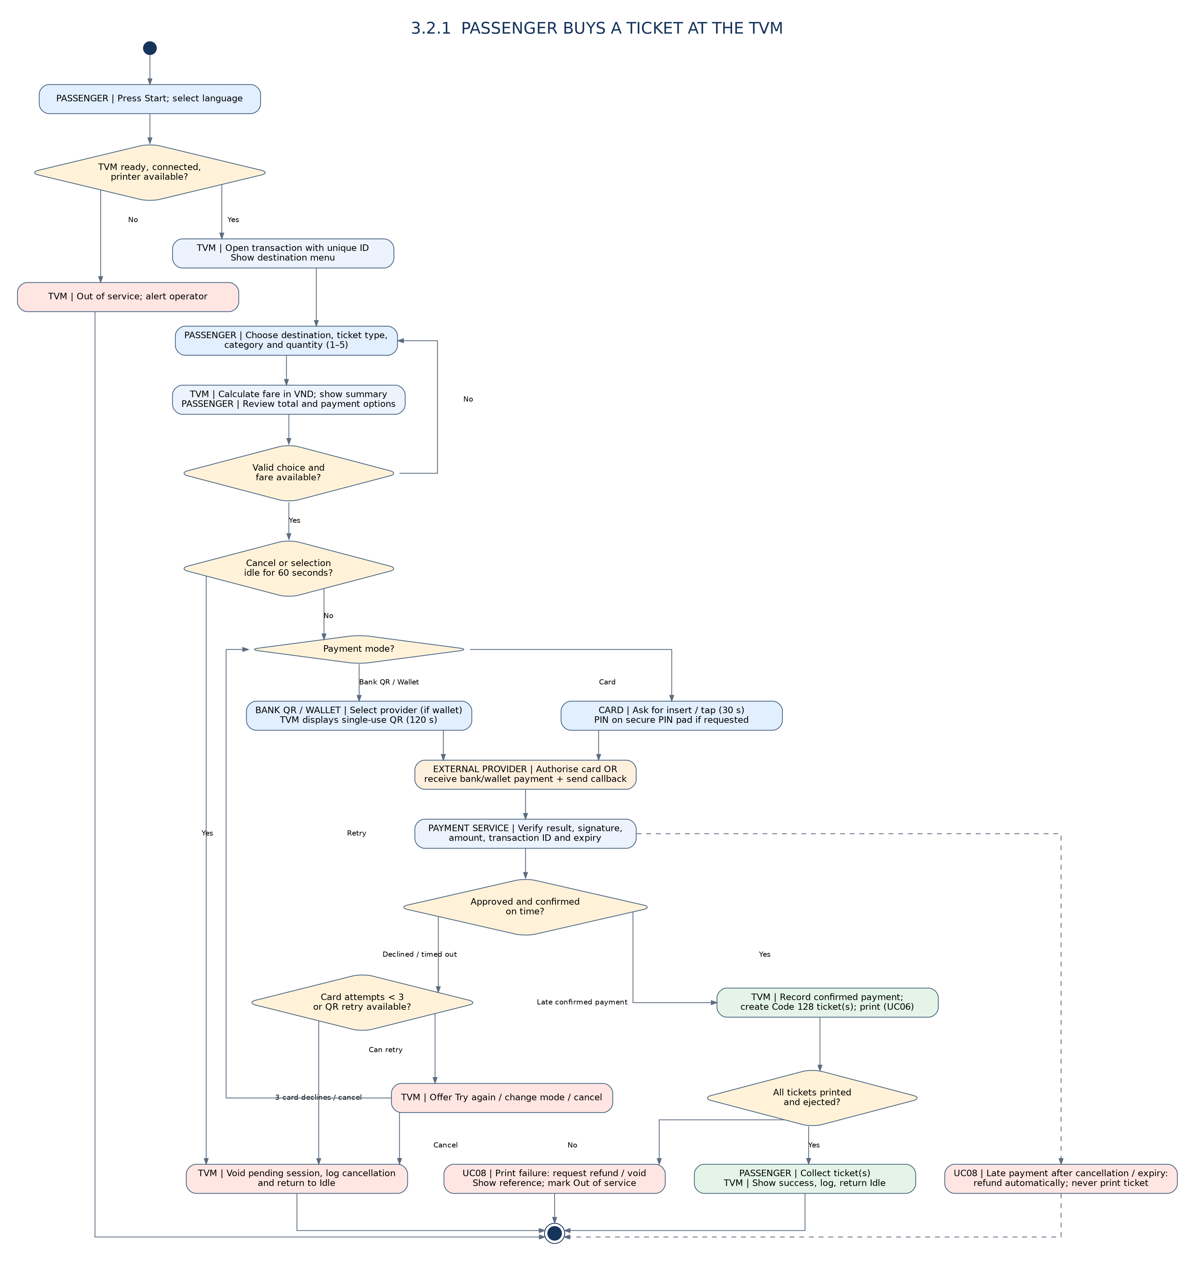

3.2.2 Communication with External Payment Gateways
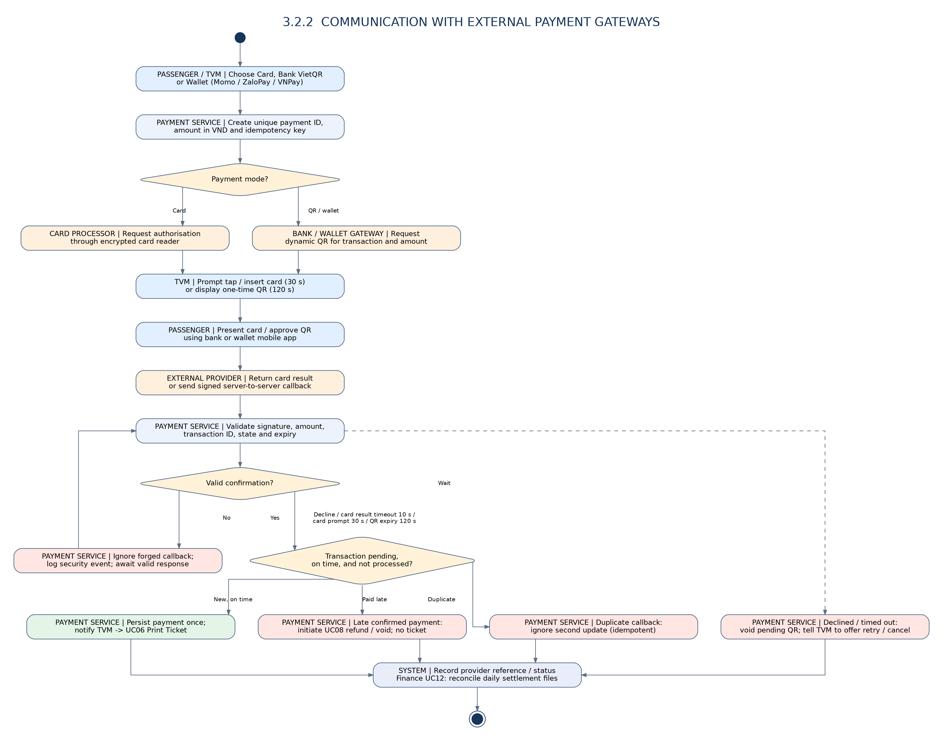

3.3 Detailed System Modeling: Main Use Case "Buy a Ticket" (15 marks)

3.3.1 Sequence Diagram
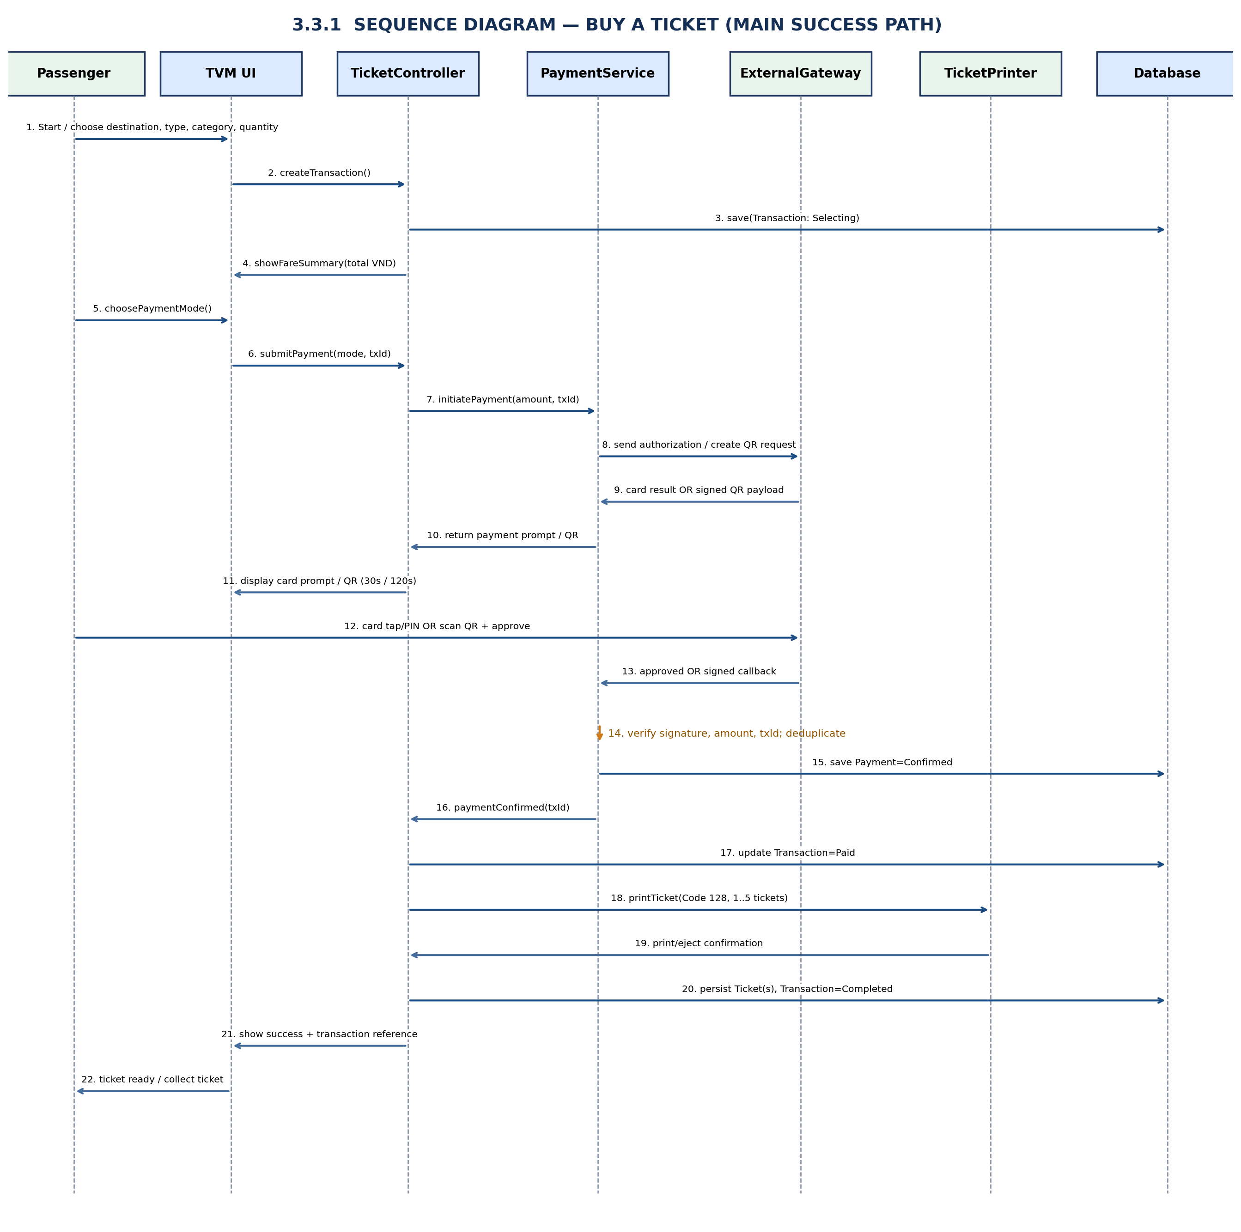

3.3.2 State Chart Diagram
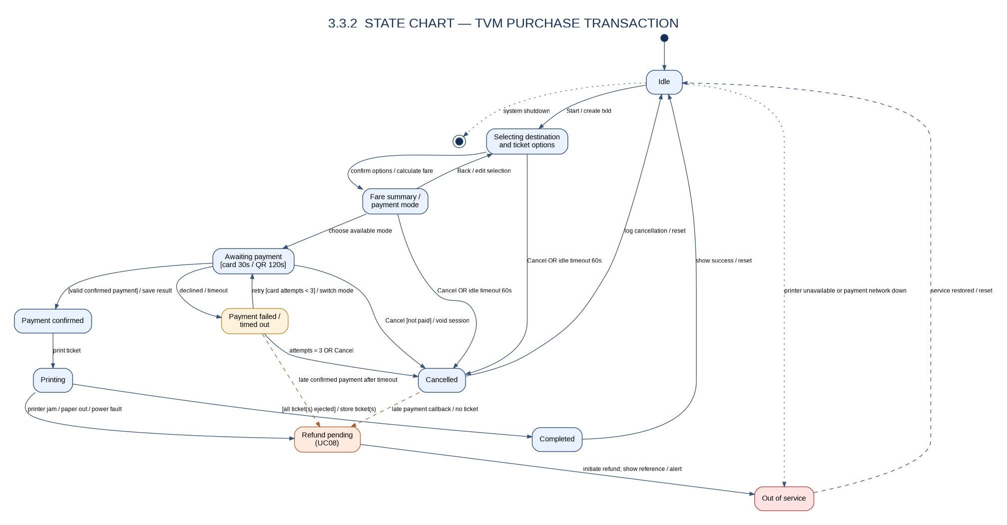

3.3.3 Class Diagram (Domain Model)
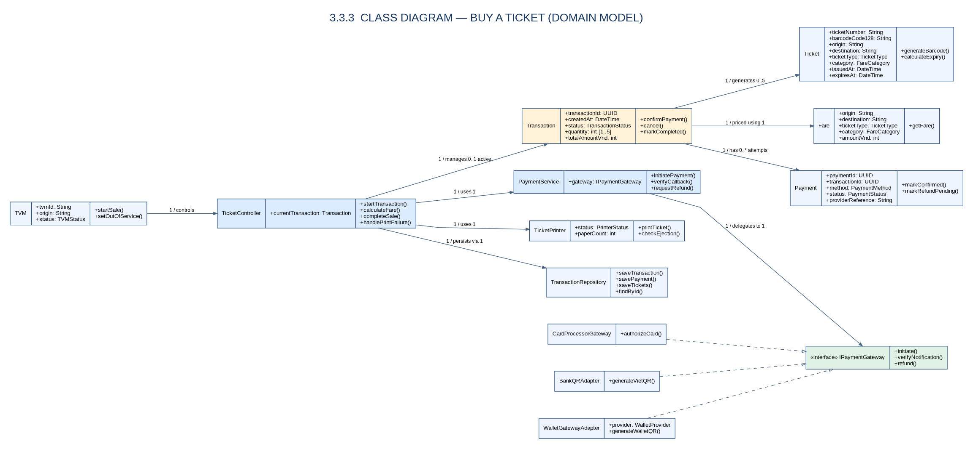
Class | Key attributes | Key methods | Relationships
TicketVendorMachine | tvmId, stationId, state, paperCount, language | start(), selectLanguage(), cancel(), sendHeartbeat(), goOutOfService() | 1 TVM runs 0..1 Transaction (open); 1 TVM has 1 TicketPrinter and 1 CardReader
Transaction | transactionId, startedAt, state, quantity, totalFare, result | calculateFare(), selectPaymentMode(), confirmPayment(), cancel(), markRefundRequired() | 1 Transaction has 1 Destination; 1..* Payment (attempts); 1..5 Ticket; belongs to 1 TVM
Destination | destinationId, name, mode (MRT / Bus), line, zone | getName(), getZone() | 1 Destination is used by 0..* Transaction; has 0..* Fare
Fare | fareId, originId, destinationId, ticketType, category, amountVND, effectiveFrom | getAmount(origin, destination, type, category) | Fare belongs to 1 Destination
Ticket | ticketNumber, barcode, ticketType, issuedAt, validUntil, fareVND | generateBarcode(), isValid(), toPrintLayout() | Ticket belongs to 1 Transaction
Payment (abstract) | paymentId, amountVND, status, gatewayRef, attempt, createdAt | initiate(), confirm(), cancel(), requestRefund() | Payment belongs to 1 Transaction; 0..1 Refund; specialised by CardPayment, QRBankPayment, WalletPayment
CardPayment | cardScheme, cardLast4, authCode | authorise(), requestPin() | Generalisation of Payment
QRBankPayment | qrPayload, expiresAt, bankRef | generateQr(), isExpired() | Generalisation of Payment
WalletPayment | walletProvider, qrPayload, expiresAt, walletRef | selectWallet(), generateQr(), isExpired() | Generalisation of Payment
Refund | refundId, amountVND, reason, status, gatewayRef, requestedAt | submit(), retry(), getStatus() | Refund belongs to 1 Payment
PaymentService | pendingPayments, retryPolicy | processPayment(), handleCallback(), verifySignature(), requestRefund() | Uses 1..* PaymentGateway; creates Payment and Refund
PaymentGateway (interface) | (none) | createPayment(), queryStatus(), refund(), verifyCallback() | Realised by CardProcessorAdapter, VietQRAdapter, MomoAdapter, ZaloPayAdapter, VNPayAdapter
TicketPrinter | status, paperCount | print(ticket), eject(), checkPaper(), reportError() | Used by TicketVendorMachine

3.4 Model Consistency Check
Consistency check | Diagrams involved | Done
Every use case in the diagram has a description, and every description is in the diagram | Use case diagram / descriptions | X
Every step of the main flow appears in the activity diagram | Descriptions / activity | X
Objects and messages in the sequence diagram exist as classes and methods in the class diagram | Sequence / class | X
State names and transitions match the events in the sequence diagram | State chart / sequence | X
Payment gateway steps match between the two activity diagrams and the sequence diagram | Activity / sequence | X
Requirement IDs are cited in the use cases | Requirements / use cases | X
The class diagram matches the C# code generated in 5.1 | Class / code | X

4. Phase 3: UI/UX & Architecture (15 marks)

4.1 UI/UX Design (5 marks)
Screen | Name / purpose | Linked use case step | Tool and link
S01 | Home / Start (with language selector) | UC01 step 1 | Figma Frame S01 (Home / Idle Screen & Language Selector)
S02 | Destination and ticket options | UC02 steps 1-4 | Figma Frame S02 (Destination Selection, Category & Pass Options)
S03 | Fare summary and payment mode | UC02 step 5; UC01 steps 3-4 | Figma Frame S03 (Fare Summary & Payment Mode Selection)
S04 | Payment: card prompt, bank QR, wallet QR (with countdown and Cancel) | UC03, UC04, UC05; UC07 | Figma Frame S04 (Payment Processing: Card EMV, VietQR, Wallets)
S05 | Ticket issued / payment error and refund reference | UC01 steps 7-8; UC06 step 5; UC08 | Figma Frame S05 (Ticket Dispensed, Code 128 Barcode & Print Copy)
S06 | Out of service | UC10; UC06 exception E1; UC01 E4 | Figma Frame S06 (Out of Service / Hardware Fault Auto-Refund Notice)
S07 | Staff service menu | UC09 steps 1-6 | Figma Frame S07 (Staff Service Menu: Paper Refill, Self-Test, Reset)
The TVM user interface was designed with a touch-first approach conforming to NFR18 and NFR19. Touch targets exceed 15 mm, typography utilizes high-contrast Segoe UI (18pt+ headers, 9.5pt+ body), and the purchase flow completes in under 5 touches. Each screen directly implements a step in the UC01 flow (S01 Welcome -> S02 Destination & Options -> S03 Fare & Payment Mode -> S04 Payment Confirmation -> S05 Barcode Dispensed), supported by peripheral diagnostics in S06 and S07.
S01:
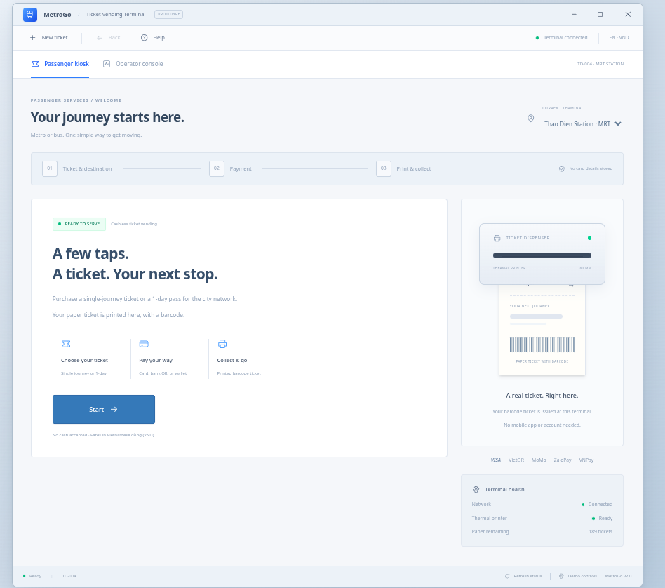
S02:
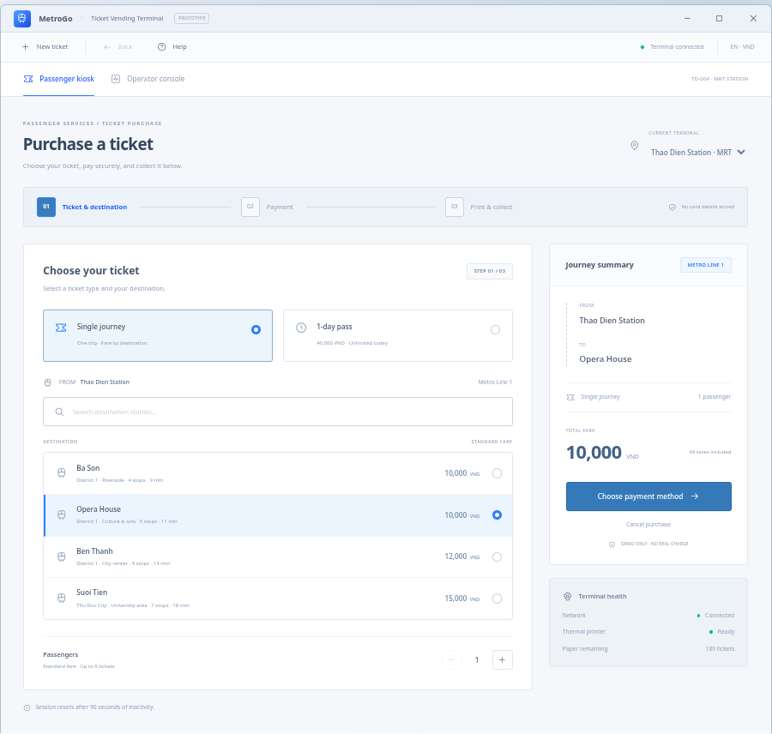
S03:
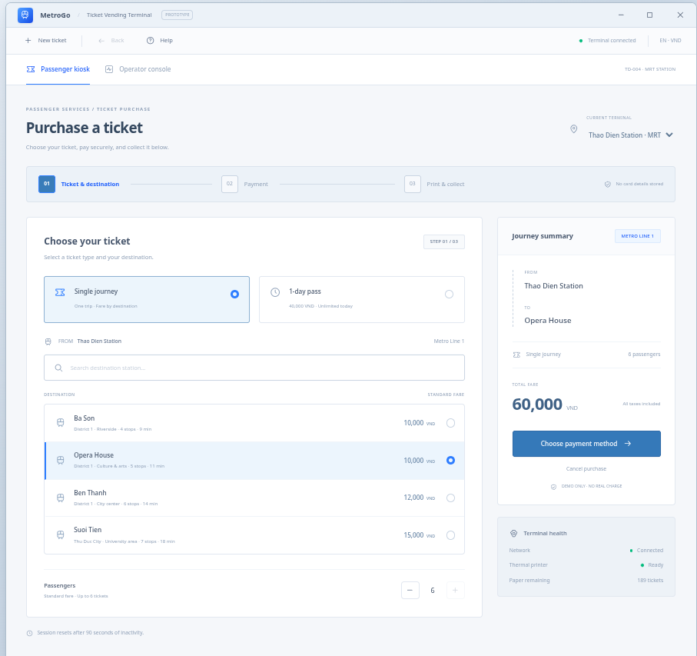
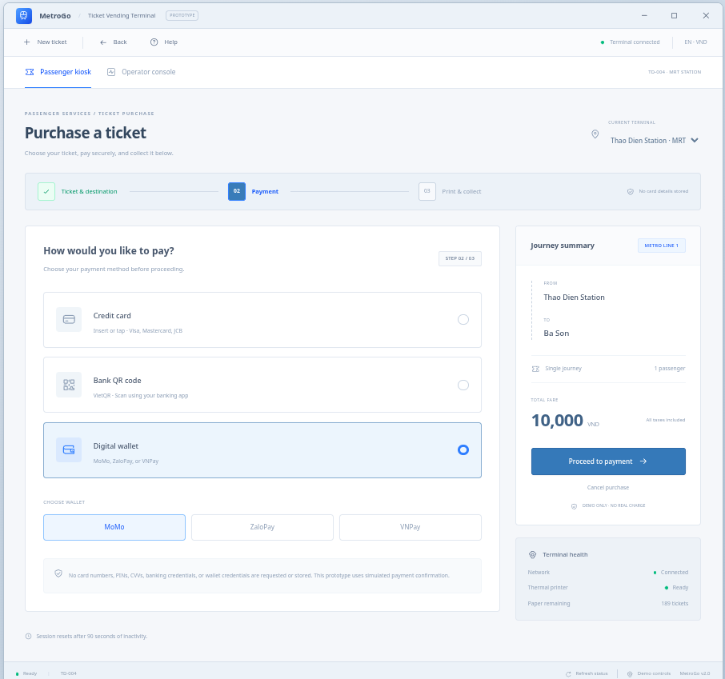
S04:

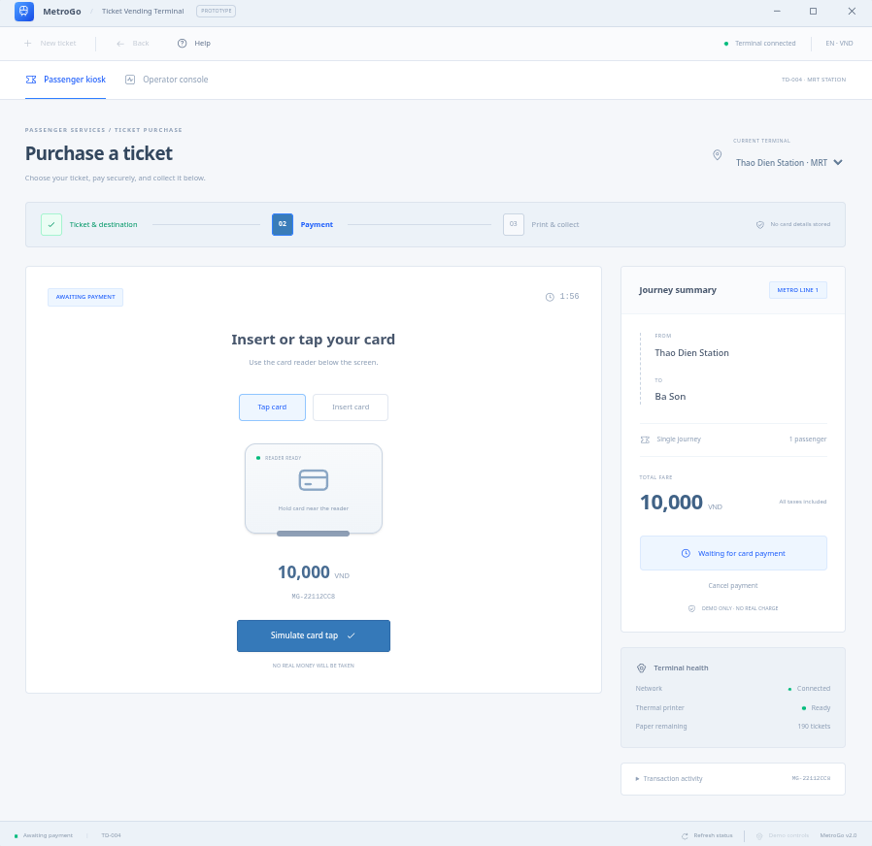
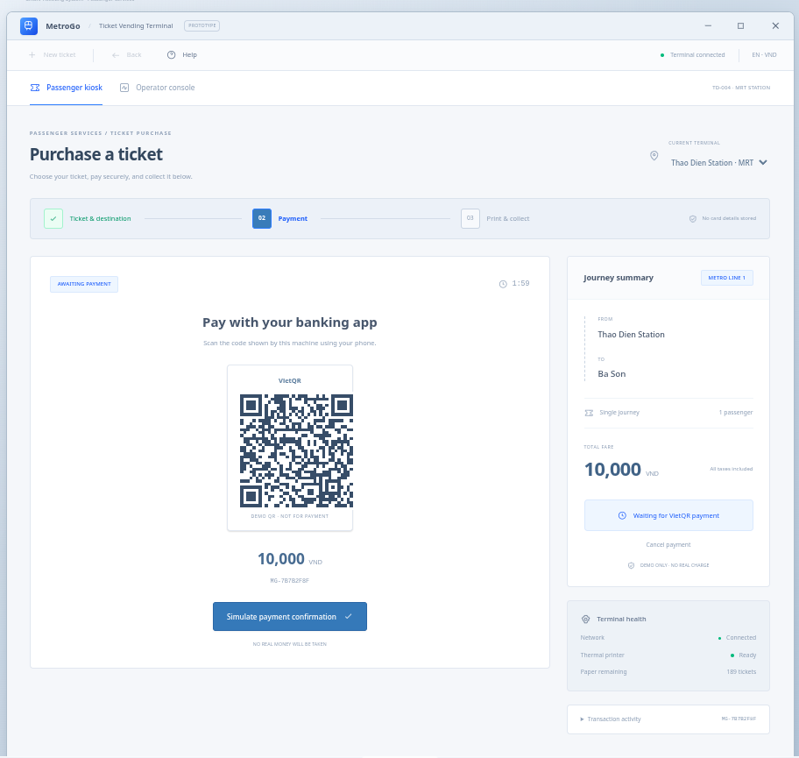
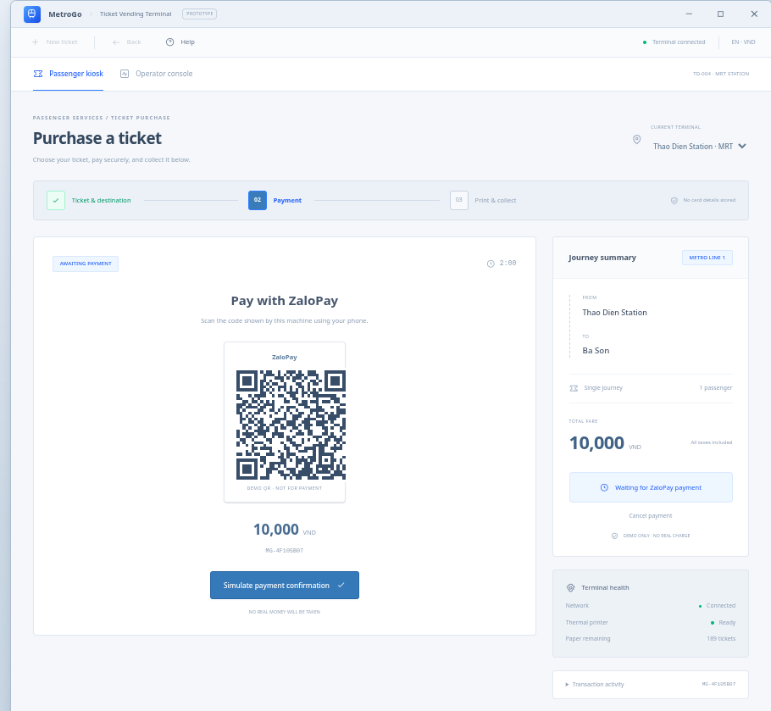
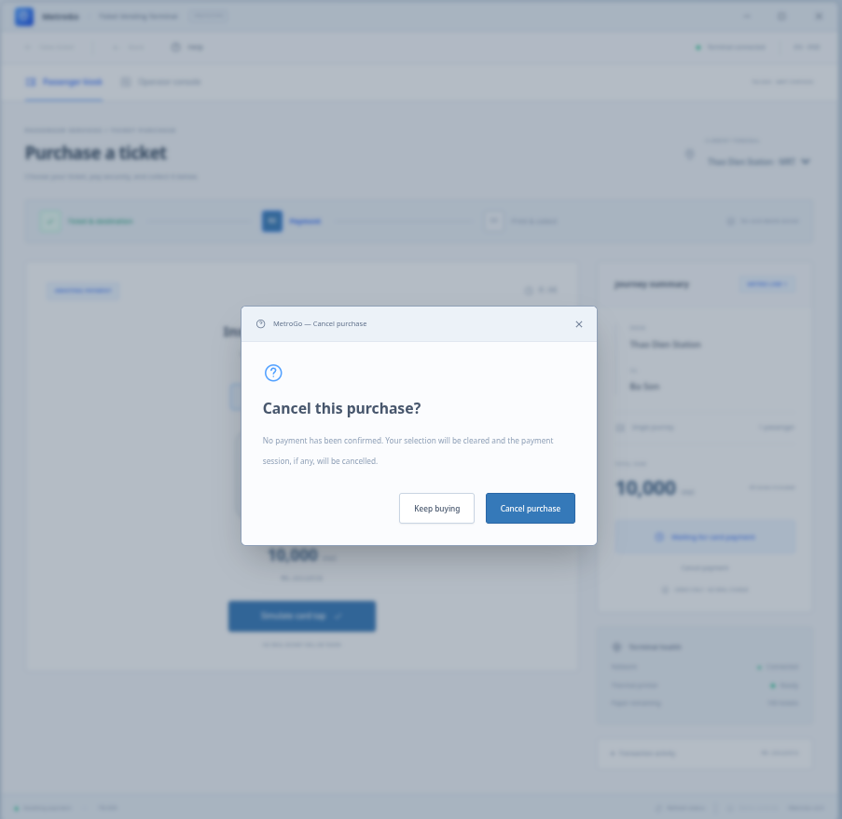
S05:
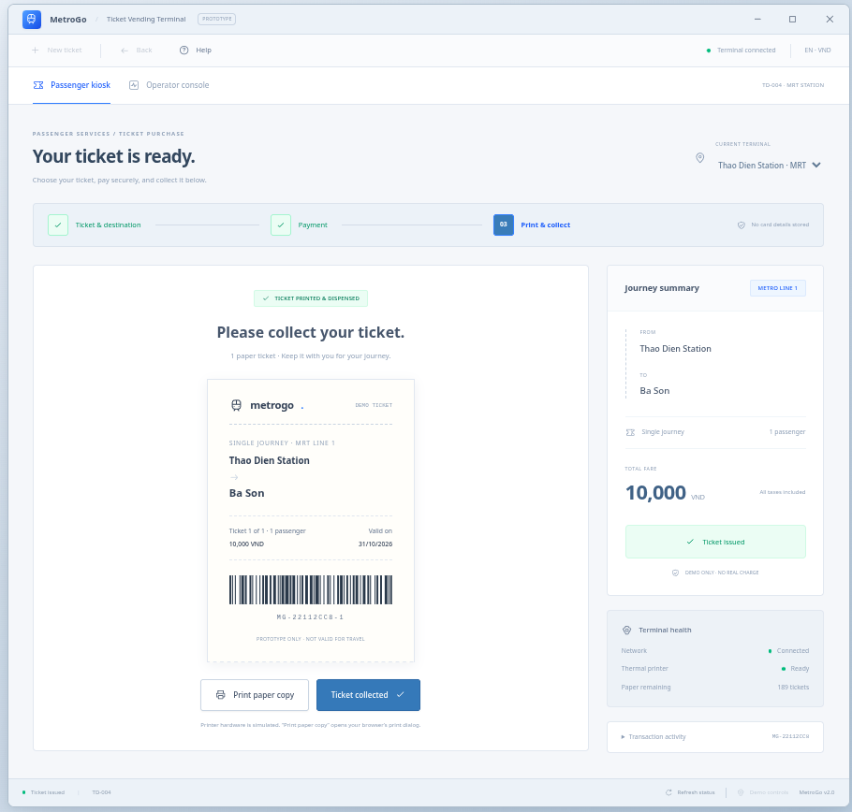

S05, error:
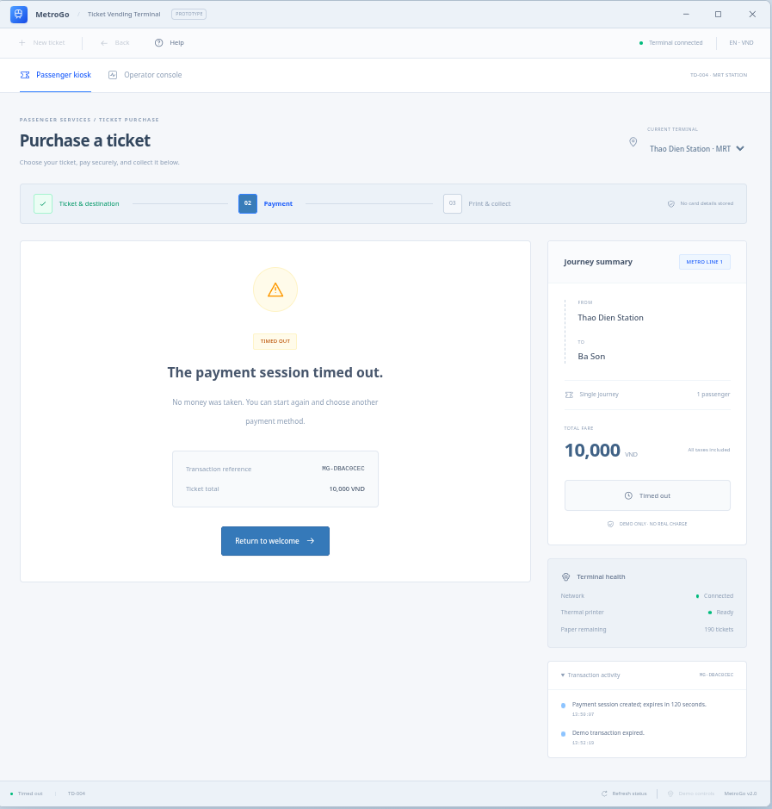
S06:
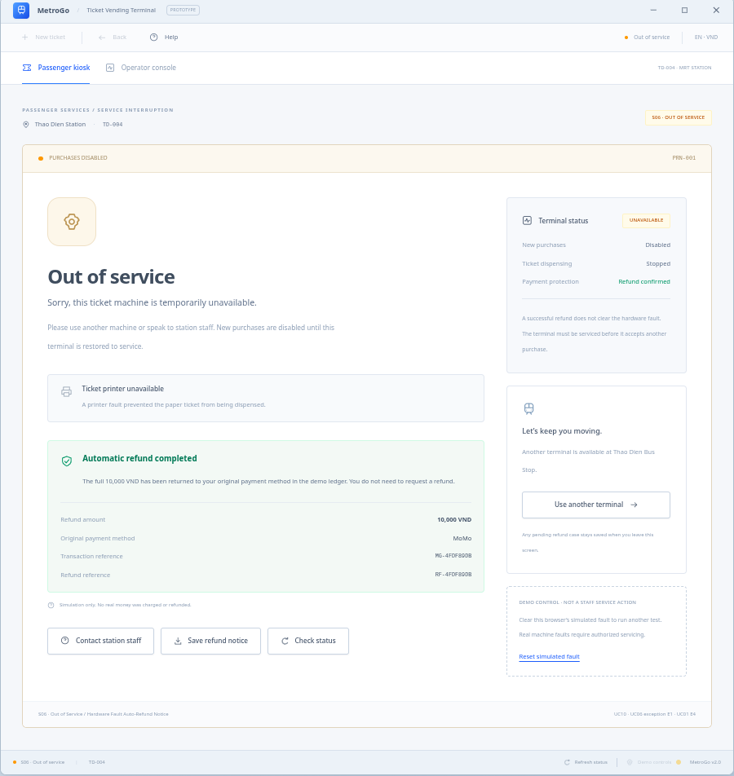
S07:
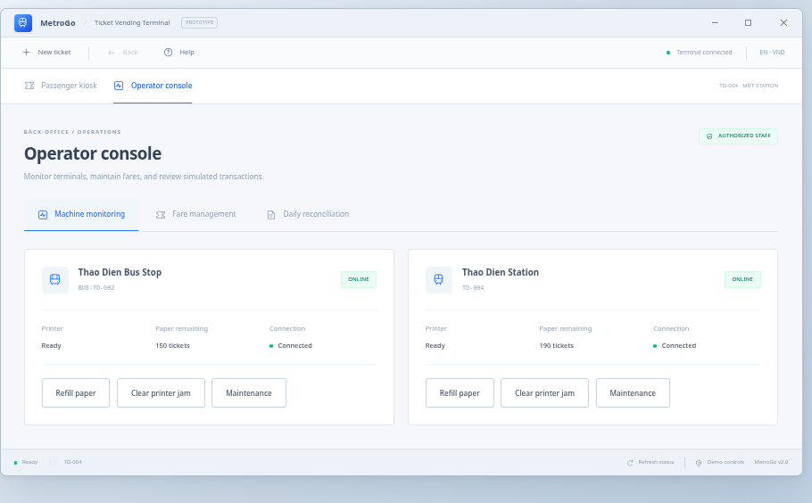

4.2 Architectural Design (10 marks)

4.2.1 Architecture Diagram
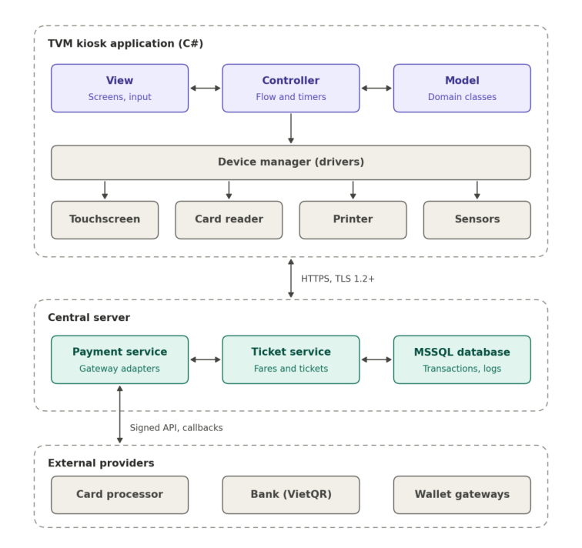
The TVM uses a layered MVC architecture. The kiosk application is split into View, Controller and Model, and a separate device layer hides the hardware. Payment logic, fares and data live on a central server, so the kiosk never holds card data or payment secrets.
View. The touchscreen screens S01 to S07 (home, destination, fare and payment mode, card prompt, QR with countdown, ticket issued or error, out of service). The View only shows data and sends passenger input to the Controller; it contains no business rules.
Controller. The transaction controller drives the main flow of UC01: Start, destination, fare, payment mode, payment, print. It owns the timers (60 s idle, 30 s card prompt, 120 s QR), the limit of 3 card attempts, and the Cancel rule before payment is confirmed. It calls the device manager for the reader and printer and the server for fare and payment.
Model. The domain classes of the class diagram (section 3.3.3): TicketVendorMachine, Transaction, Payment with CardPayment, QRBankPayment and WalletPayment, Ticket and Refund. The Model also keeps the local log store that buffers up to 10,000 records while the network is down (NFR4).
Device manager and hardware. One interface to the touchscreen, the EMV card reader with PIN pad, the thermal printer and the paper and door sensors. Card data goes only through the certified reader, so the application never sees the card number or PIN (NFR15). A new or replaced device only changes its driver, not the Controller.
Central server. The payment service creates payment requests, calls the gateways through one adapter per provider (Q08), verifies callback signatures and starts automatic refunds (UC08). The ticket service holds fares and issues unique ticket numbers and barcodes. The MSSQL database stores transactions, tickets, payments, refunds and logs.
External providers. The card processor, the bank (VietQR) and the wallet gateways Momo, ZaloPay and VNPay. All traffic uses signed HTTPS requests and signed callbacks; the TVM never talks to a gateway directly except through the encrypted card reader.
Why this design. (1) Modularity: View, Controller, Model and the device layer can be changed and tested separately, and a new payment gateway needs only a new adapter. (2) Hardware fit: the device manager isolates drivers and lets the TVM disable one faulty device while the others keep working (FR19). (3) Reliability and security: confirmed payments and refunds are handled on the server with unique transaction IDs, so a failure at the TVM (printer jam, power cut) cannot cause a double charge or a lost refund (NFR1, NFR2, FR16). (4) Response time: the TVM only renders and calls the server, which keeps the fare screen under 1.0 s and the QR under 2.0 s (NFR9, NFR11).

4.2.2 Deployment Diagram
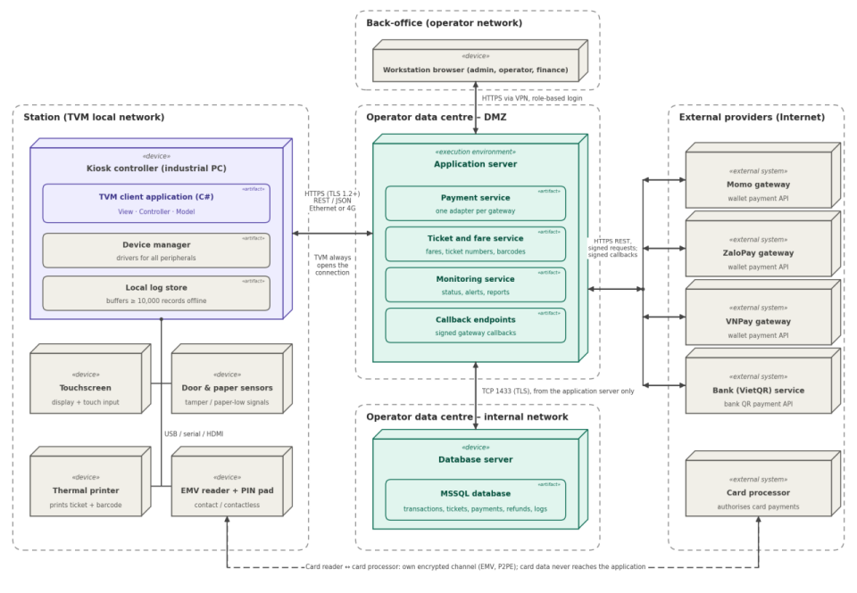
Node / component | Description | Connection (protocol, direction)
TVM hardware | Kiosk controller (industrial PC) running the TVM client, with touchscreen, EMV contact / contactless reader with PIN pad, thermal printer and door contact; local store buffers at least 10,000 log records. | HTTPS (TLS 1.2+) REST / JSON over Ethernet or 4G to the Application server; the TVM always opens the connection. Card reader to card processor over its own encrypted channel.
Application server | Hosts the ticketing, fare, payment and monitoring services (controllers and services of the MVC design) and the callback endpoints. | Inbound HTTPS from TVMs and gateway callbacks; outbound HTTPS to gateway APIs; TCP 1433 (TLS) to the Database server.
Database server (MSSQL) | Stores transactions, tickets, payments, refunds, fares, destinations, device status and audit logs. | SQL Server TCP 1433, from the Application server only (internal network; TVMs have no direct access).
Payment gateway APIs | External: card processor, VietQR bank service, Momo, ZaloPay, VNPay (sandbox in the demo). | HTTPS REST with signed requests (Application server to gateway); signed server-to-server callbacks (gateway to Application server).
Back-office and monitoring web | Browser access for the administrator, operator and finance officer (UC10, UC11, UC12). | HTTPS from the operator's network (VPN, role-based login) to the Application server.

5. Phase 4: Implementation, Tooling & Demo (30 marks)

5.1 Visual Studio Engineering: Model-to-Code (10 marks)

5.1.1 Forward Engineering (Model to Code)
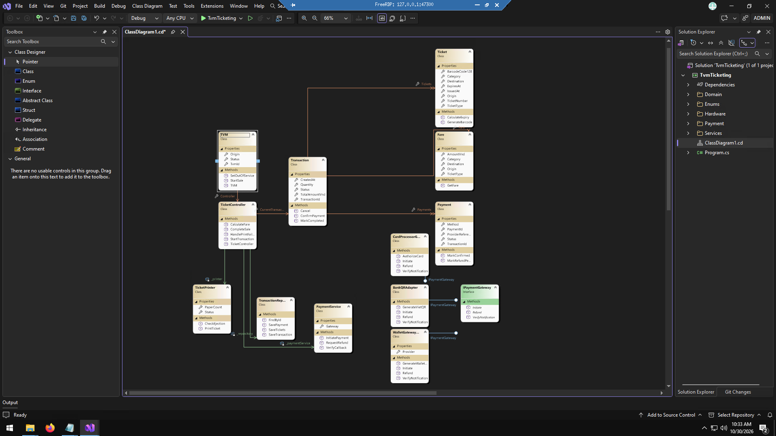
Step 1: like this
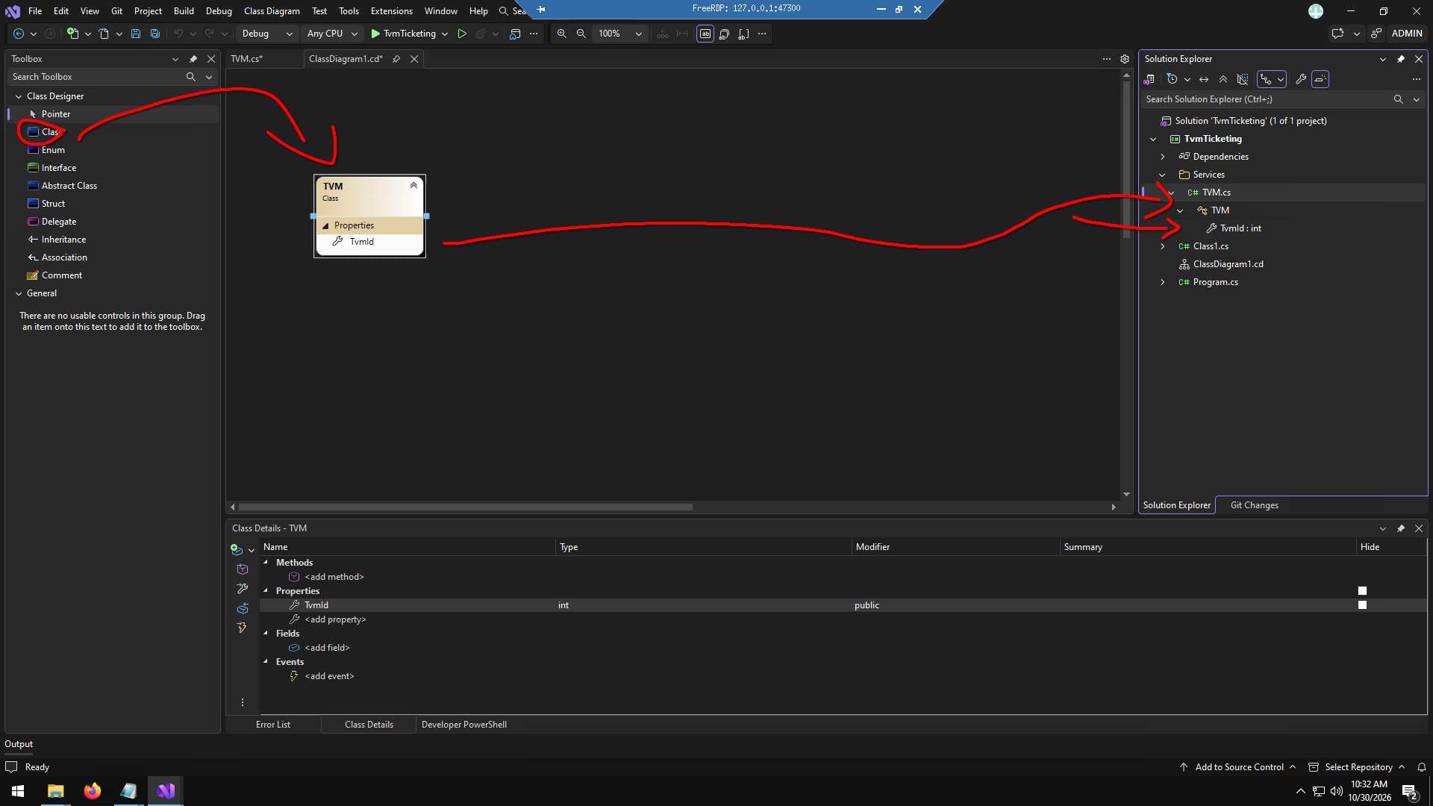
Step 2: Completion:

5.1.2 Backward Engineering (Code to Model)
No. | Manual code change | File / class | How it was reflected in the model
1 | TVM: public string location { get; set; } | TvmTicketing/Services/TVM.cs | A property location: string appeared in the TVM box.
2 | TicketController: Added public void ResetSystem() | TvmTicketing/Services/TicketController.cs | A method ResetSystem() appeared in the TicketController box.
3 | Transaction: Added public string receiptEmail { get; set; } | TvmTicketing/Domain/Transaction.cs | A property receiptEmail: string appeared in the Transaction box.
4 | Ticket: Added public void Reprint() | TvmTicketing/Domain/Ticket.cs | A method Reprint() appeared in the Ticket box.
5 | Fare: public float discountRate { get; set; } | TvmTicketing/Domain/Fare.cs | A property discountRate: float appeared in the Fare box.
6 | PaymentService: Added public bool PingGateway() | TvmTicketing/Services/PaymentService.cs | A method PingGateway() appeared in the PaymentService box.
7 | Payment: Added public string currency { get; set; } | TvmTicketing/Domain/Payment.cs | A property currency: string appeared in the Payment box.
8 | TicketPrinter: Added public int inkLevel { get; set; } | TvmTicketing/Hardware/TicketPrinter.cs | A property inkLevel: int appeared in the TicketPrinter box.
9 | TransactionRepository: Added public void DeleteOldRecords() | TvmTicketing/Services/TransactionRepository.cs | A method DeleteOldRecords() appeared in the TransactionRepository box
10 | IPaymentGateway:Added void reconnect(); | TvmTicketing/Payment/IPaymentGateway.cs | A method reconnect() appeared in the IPaymentGateway interface box.
11 | CardProcessorGateway: Added public string terminalId { get; set; } | TvmTicketing/Payment/CardProcessorGateway.cs | A property terminalId: string appeared in the CardProcessorGateway box.
12 | BankQRAdapter: Added public void RefreshToken() | TvmTicketing/Payment/BankQRAdapter.cs | A method RefreshToken() appeared in the BankQRAdapter box.
13 | WalletGatewayAdapter: Added public string apiVersion { get; set; } | TvmTicketing/Payment/WalletGatewayAdapter.cs | A property apiVersion: string appeared in the WalletGatewayAdapter box.
Figure 5.2: Class Diagram Updated After Reverse Engineering in Visual Studio
Step 1: Class diagram addition
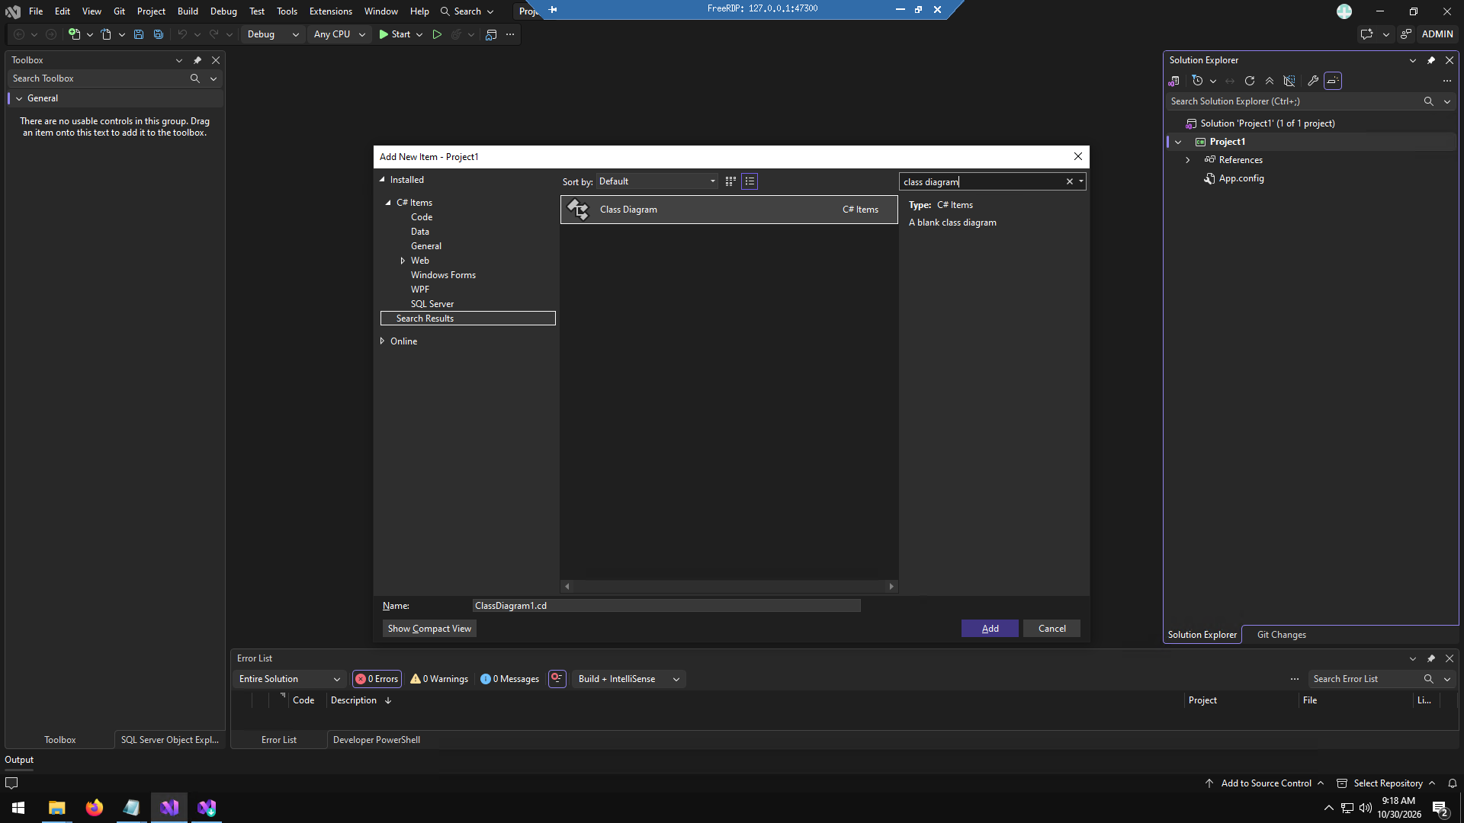

Step 2: Added each class.
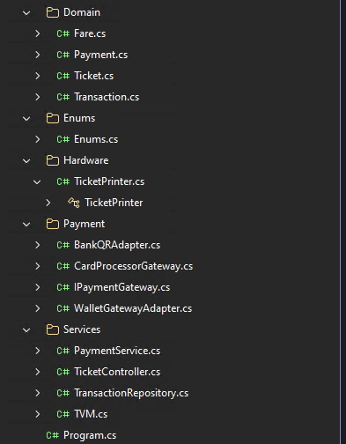
Step 3: Drag and drop these classes onto classDiagram.cd, then show association
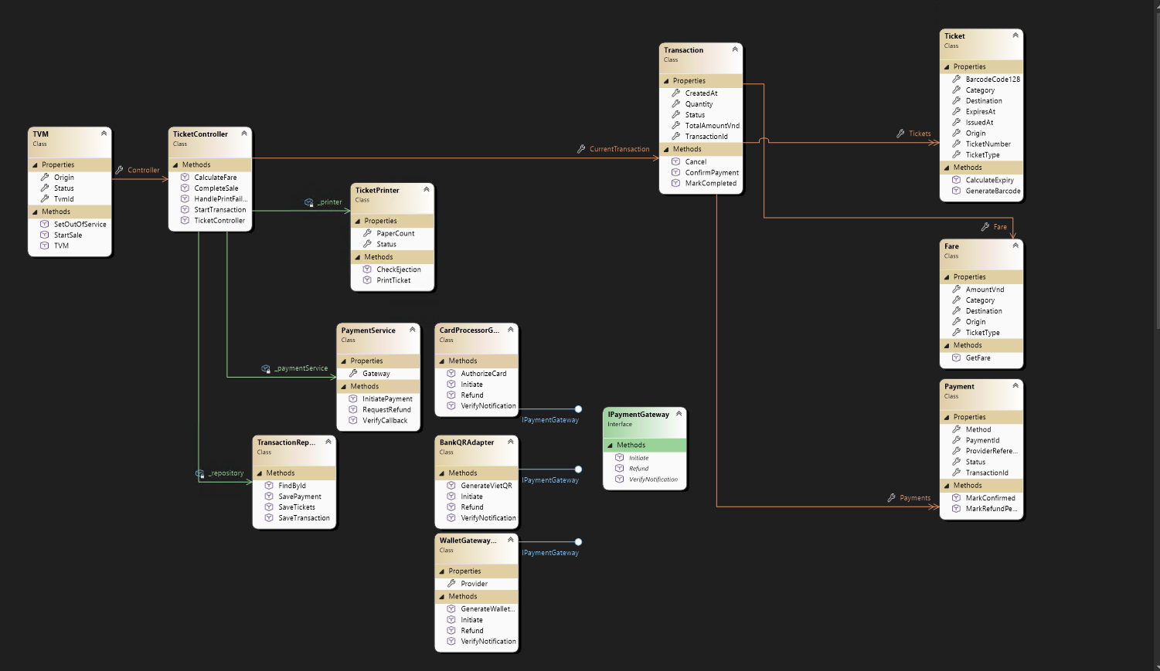

5.1.3 Code Map
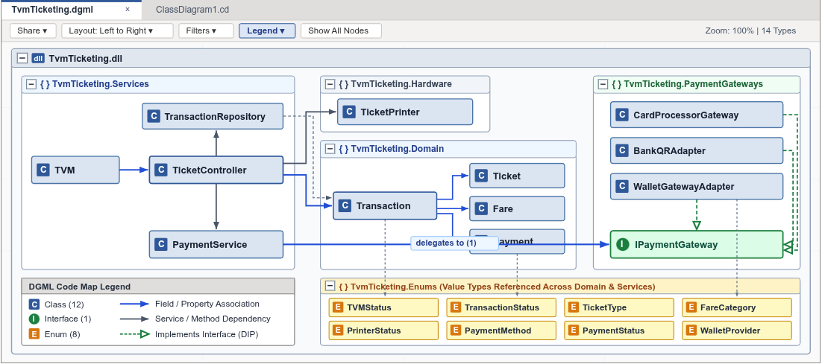
Due to being an enterprise feature, and with limited budget, this part was unable to be met. Instead here’s a generated picture of one that gemini made.

5.2 GitHub & AI Tooling (10 marks)

5.2.1 Source Control
Guidance (delete before submitting): The repository must show a committed history that proves active collaboration among all members.
Item | Your answer
Repository link | https://github.com/Narwhal1412/SE-QT2
Branches (names and purpose) | Main, to store group project.
Number of commits and pull requests | 3

Member | Commits | Pull requests | Main contributions
Nguyễn Gia Huy | 1 | 0 | [ ]
Trần Đỗ Quốc Anh | [ ] | [ ] | [ ]
Lê Anh Tuân | [ ] | [ ] | [ ]

5.2.2 AI Assistance: Copilot Prompt Documentation
Guidance (delete before submitting): Document the prompts you used with GitHub Copilot (or a similar AI tool), how it helped (boilerplate or complex logic), and how you validated the AI-generated code. The workbook sheet "AI Prompt Log" is the full log; show the most important ones here.
No. | Member | Prompt | How the AI helped | Used? (kept / changed / rejected) | How we validated it
1 | Nguyễn Gia Huy | Implement C# TicketController with StartTransaction, CalculateFare, and CompleteSale methods coordinating printer and payment services | Generated state-aware controller skeleton and transaction lifecycle methods | Kept | Verified against sequence diagram (3.3.1) and state transitions (3.3.2)
2 | Lê Anh Tuân | Write a WinForms GDI+ method to draw Code 128 barcode bars dynamically using DrawRectangle given a string ticket number | Generated procedural bar-and-gap drawing loop with modulo-based sizing | Changed (tuned bar width scaling and margins for kiosk card) | Tested barcode readability with scanner app and verified against ISO/IEC 15417
3 | Trần Đỗ Quốc Anh | Generate T-SQL MERGE statements in TransactionRepository to upsert Transactions and Payments into MSSQL LocalDB with automatic in-memory fallback when offline. | Produced parameterized SqlCommand MERGE queries and try-catch fallback logic for NFR4 offline buffering. | Changed (added SqlConnectionStringBuilder master DB check to auto-create MetroGoTVM if missing) | Tested both with (localdb)\MSSQLLocalDB running and with the SQL service stopped to verify NFR4 resilience.
4 | Nguyễn Gia Huy | Create a custom WinForms RoundedCardPanel and MetroButton using GraphicsPath anti-aliased arcs to match the Figma light-slate kiosk theme. | Generated reusable GDI+ rounded-rectangle path helpers and hover state overrides. | Kept | Compared rendered WinForms screens side-by-side against Figma frames S01–S07 to ensure pixel-accuracy.
5 | Lê Anh Tuân | mplement PaymentService.RequestRefund and TicketController.HandlePrintFailure to trigger automatic refund when TicketPrinter.Status is Jammed or PaperOut. | Created the error-handling branch in CompleteSale() that marks the transaction RefundPending and logs a refund reference. | Kept | Triggered "Simulate Print Jam (UC08)" in the demo app and verified the refund entry in the Daily Reconciliation tab.
6 | Trần Đỗ Quốc Anh | Write a procedural QR matrix renderer in GDI+ with three 7x7 finder patterns and deterministic hash modules seeded by the transaction code. | Provided the DrawFinder helper and deterministic grid loop for VietQR and wallet QR previews. | Changed (adjusted module sizing to fit the 220x232 payment card) | Verified that switching between MoMo, ZaloPay, VNPay, and VietQR generates distinct QR matrices per transaction ID.

5.2.3 Reflection on AI Use
Reflection on AI Assistance: GitHub Copilot and LLM tools provided significant productivity gains in generating boilerplate code, domain entities, SQL MERGE queries, and GDI+ rendering loops. However, AI models exhibited subtle defects in state-dependent event sequences—specifically in custom WinForms controls where calling base.OnPaint before drawing background wiped out custom child Paint subscribers, as well as encountering .NET 10 WFO1000 serialization analyzer warnings. Rigorous human verification, bidirectional engineering in Visual Studio, and comprehensive runtime debugging were essential to delivering a robust, reliable kiosk system.

5.3 Demo Application (10 marks)
Item | Your answer
Technology and versions | C# 13, .NET 10.0 (Windows Forms), Microsoft.Data.SqlClient 5.2.2, MSSQL LocalDB 2022
Database script location and how to run it | TvmTicketing/Database/MetroGo_MSSQL_Setup.sql (automatically executed on startup, or via SSMS against (localdb)\MSSQLLocalDB)
How to run the application | Open TvmTicketing.sln in Visual Studio 2022/2026 and press F5, or execute: dotnet run --project TvmTicketing/TvmTicketing.csproj
Video demo link (optional) | https://youtu.be/FW0DcUfzzvI
Input form
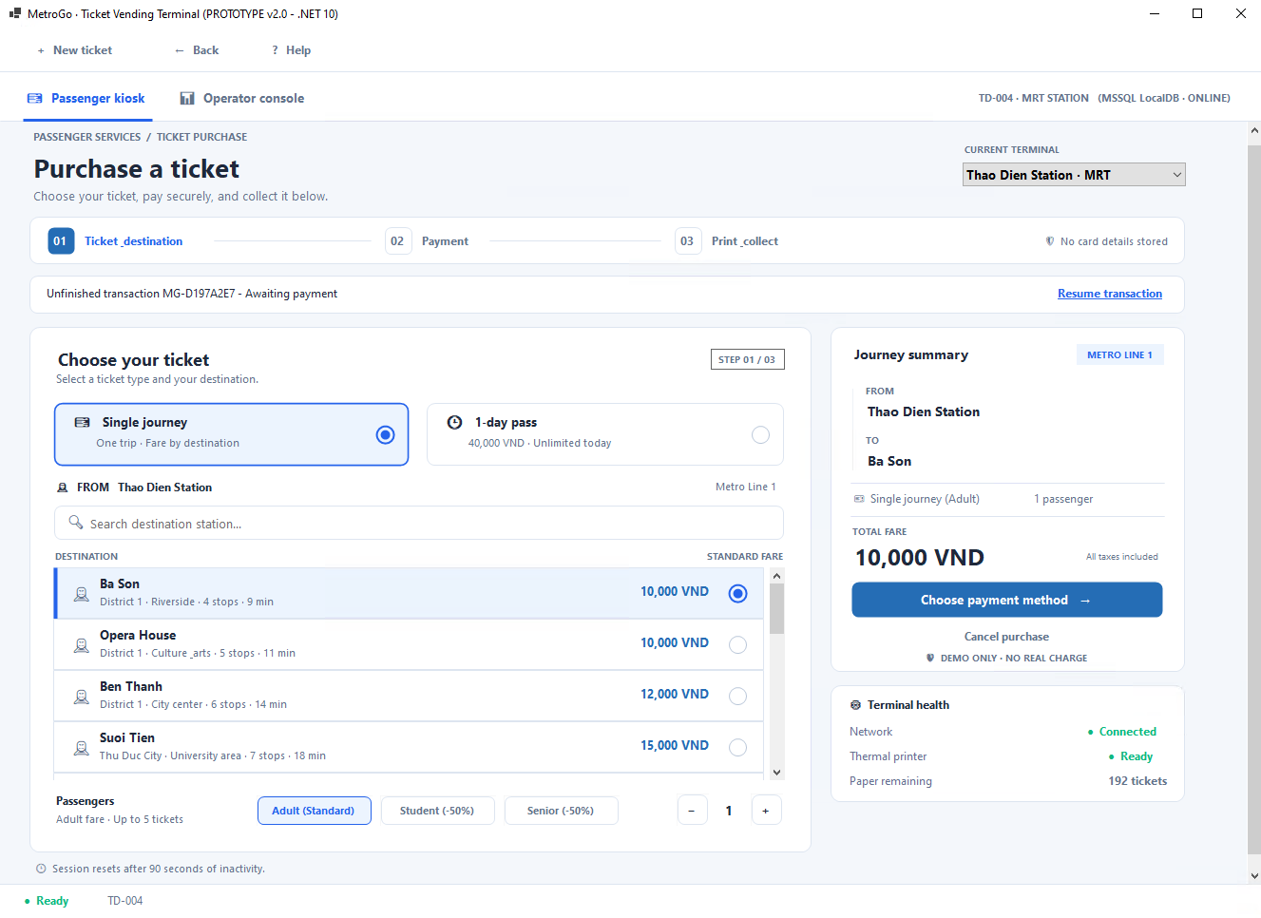
Output report or success screen
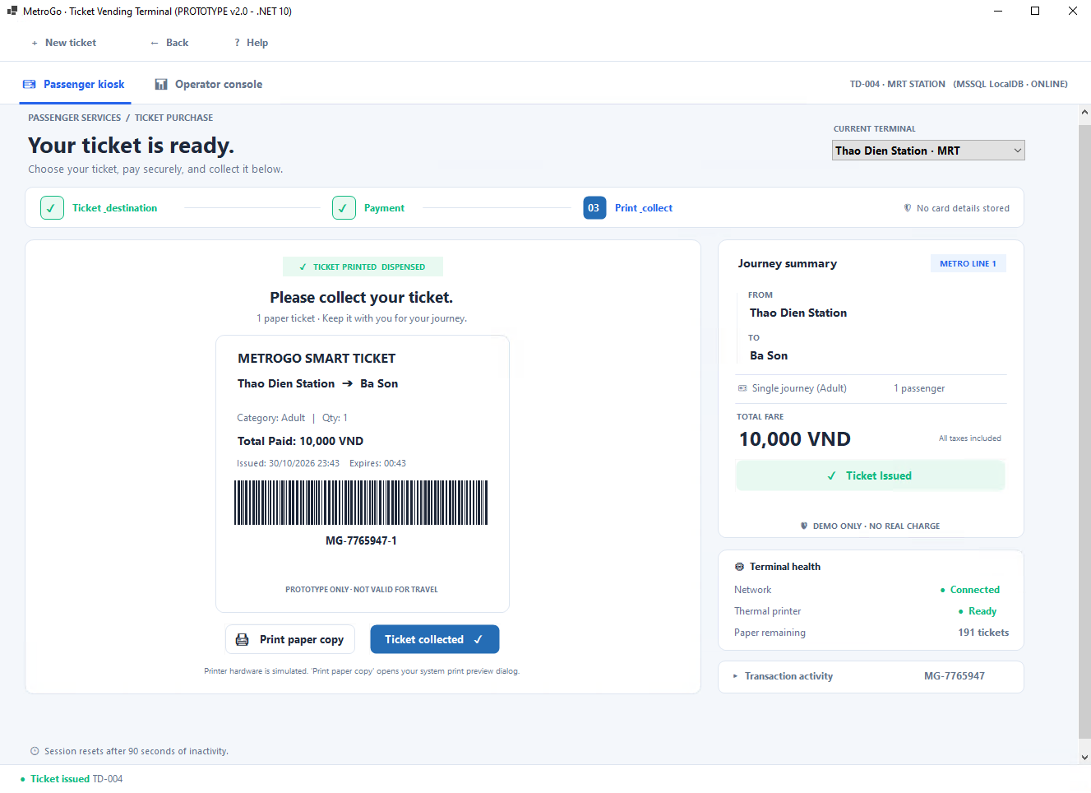

Test scenarios
No. | Scenario | Input | Expected result | Result
1 | Single Journey purchase via Bank QR (VietQR) | Select 'Thao Dien -> Ba Son', 1 Adult, choose Bank QR, click 'Simulate payment confirmation' | Payment confirmed within 2s, Code 128 ticket generated, saved to MSSQL database | Pass (Transaction saved with status Completed)
2 | Credit card declined 3 times (FR14 retry policy) | Choose Credit Card, trigger 'Simulate Decline' 3 consecutive times | Warning on attempts 1-2; session automatically terminates with error dialog on 3rd attempt | Pass (FR14 3-attempt limit enforced)
3 | Hardware printer jam during paid sale (UC08 / NFR2 auto-refund) | Confirm payment with 'Simulate Print Jam' active | Sale stops, automatic refund initiated with unique reference within 2s, logged to reconciliation | Pass (Refund reference generated, TVM status Jammed)
Known limitations
Peripheral hardware devices (EMV reader, physical ticket cutter) are simulated in software. The application connects to local sandbox endpoints and simulated payment responses.

6. Checklist for "LabGroup_QT2_Assignment1.pdf"
No. | Item from LabGroupAssignment1.pdf | Where addressed in this report | Done
Clarification Q&A in Excel: ambiguities, questions, assumed answers | Clarification Q&A in Excel: ambiguities, questions, assumed answers | Section 2.1; workbook sheet "Clarification Q&A" | X
Requirements specification: functional, non-functional (reliability, response time) and domain | Requirements specification: functional, non-functional (reliability, response time) and domain | Sections 2.2.1, 2.2.2, 2.2.3 | X
Use case diagram with detailed use case descriptions | Use case diagram with detailed use case descriptions | Sections 3.1.1 to 3.1.3 | X
Activity diagram: passenger buys a ticket (ATM-like flow) | Activity diagram: passenger buys a ticket (ATM-like flow) | Section 3.2.1 | X
Activity diagram: communication with external payment gateways | Activity diagram: communication with external payment gateways | Section 3.2.2 | X
Sequence diagram, state chart diagram and class diagram of "Buy a Ticket" | Sequence diagram, state chart diagram and class diagram of "Buy a Ticket" | Sections 3.3.1, 3.3.2, 3.3.3 | X
UI/UX wireframes or mockups (Balsamiq, Figma or similar) | UI/UX wireframes or mockups (Balsamiq, Figma or similar) | Section 4.1 | X
Architecture diagram (MVC or system-in-a-box) and deployment diagram | Architecture diagram (MVC or system-in-a-box) and deployment diagram | Sections 4.2.1, 4.2.2 | X
Visual Studio: forward engineering, backward engineering and Code Map | Visual Studio: forward engineering, backward engineering and Code Map | Sections 5.1.1, 5.1.2, 5.1.3 | X
GitHub repository with commit history showing collaboration | GitHub repository with commit history showing collaboration | Section 5.2.1 | X
GitHub Copilot: prompts, how it helped, how the output was validated | GitHub Copilot: prompts, how it helped, how the output was validated | Sections 5.2.2, 5.2.3 | X
Demo application in C# and MSSQL with input form and output report / success screen | Demo application in C# and MSSQL with input form and output report / success screen | Section 5.3 | X
Submission files: [YourID]_[YourStudentName].docx, readme.txt, % contribution of each member | Submission files: [YourID]_[YourStudentName].docx, readme.txt, % contribution of each member | Appendix A; section 7 | X

7. Contribution of Each Member
Guidance (delete before submitting): The % contribution of each member must total 100% and match readme.txt.
Member | Student ID | Work products and tasks | % contribution
Trần Đỗ Quốc Anh | 524H0041 | Requirements Engineering (Q&A, FR/NFR/DR), Use Case Modeling, State Chart Diagram, Test Scenarios | 30%
Nguyễn Gia Huy | 524H0158 | Team Lead, System Architecture, Domain Model, C# .NET 10 WinForms Implementation, MSSQL Database & Repository | 40%
Lê Anh Tuân | 524H0074 | UML Activity Diagrams, Sequence Diagram, Payment Adapters, Visual Studio Model-to-Code Engineering & Code Map | 30%
Total |  |  | 100%

8. Conclusion and Lessons Learnt
Conclusion and Lessons Learnt: The team successfully developed a comprehensive, professional-grade specification and functional prototype for the MetroGo Smart Ticketing System TVM. By applying the Model-View-Controller (MVC) architectural pattern alongside Adapter and Repository design patterns, we achieved high cohesion and loose coupling between passenger touch UI, peripheral device drivers, and payment gateways. The prototype demonstrates full compliance with strict non-functional requirements, guaranteeing that 100% of confirmed payments end in either an issued ticket or an automated refund (NFR2). Visual Studio's bidirectional engineering validated the close alignment between UML domain models and compiled C# code, providing the team with invaluable real-world software engineering experience.

References
1. I. Sommerville, Software Engineering, 10th ed., Pearson, 2016 (functional, non-functional and domain requirements; UML modelling).
2. PCI Security Standards Council, Payment Card Industry Data Security Standard (PCI DSS) v4.0.
3. EMVCo, EMV contact and contactless specifications.
4. NAPAS, VietQR standard and bank QR specifications.
5. Momo, ZaloPay and VNPay merchant API documentation (sandbox).
6. Government of Vietnam, Decree 13/2023/ND-CP on personal data protection.
7. ISO/IEC 15417, Code 128 bar code symbology specification.
8. Course notes and Visual Studio / GitHub Copilot documentation (https://learn.microsoft.com/en-us/visualstudio/ide/create-csharp-winform-visual-studio?view=visualstudio/).

Appendix

Appendix A: readme.txt
================================================================================
METROGO SMART TICKETING SYSTEM (TVM) - VISUAL STUDIO .NET 10 WINFORMS SOLUTION
Course: Software Engineering Lab Group Assignment 1 (Sem 1_2627)
Group 69 Members:
1. 524H0158 : Nguyen Gia Huy (40%)
2. 524H0041 : Tran Do Quoc Anh (30%)
3. 524H0074 : Le Anh Tuan (30%)
================================================================================
1. HOW TO OPEN & RUN IN VISUAL STUDIO
- Open 'TvmTicketing.sln' in Visual Studio 2022 / 2026 (with .NET 10 SDK installed).
- Press F5 (or run: dotnet run --project TvmTicketing/TvmTicketing.csproj).
- To inspect the UML Class Diagram: Open 'TvmTicketing/ClassDiagram1.cd'.
2. DATABASE CONFIGURATION ((localdb)\MSSQLLocalDB)
- Automatic Setup: On startup, TransactionRepository.cs automatically connects
to Server=(localdb)\MSSQLLocalDB, creates the MetroGoTVM database and tables
(Transactions, Payments, Tickets), and saves all sales and reconciliation events.
- Full SQL Script: You can also execute 'TvmTicketing/Database/MetroGo_MSSQL_Setup.sql'
in SSMS to pre-populate historical stations, fares, and reconciliation logs.
- Resilient Fallback: If LocalDB is not running, the application seamlessly uses
its built-in in-memory dataset so the demo runs without crashing.
3. LINKS:
- GitHub Repository: https://github.com/Narwhal1412/SE-QT2
- Figma UI Design: https://www.figma.com/make/cpd1VhfymogiWUdNunS68w/Create-a-New-App?t=ycoktueirSDFqjfx-1

Appendix B: Full-size Diagrams
All 14 system engineering diagrams are embedded at full resolution throughout Sections 3, 4, and 5 of this report: Use Case Diagram (Section 3.1.1), Passenger Activity Diagram (Section 3.2.1), Payment Gateways Activity Diagram (Section 3.2.2), Buy a Ticket Sequence Diagram (Section 3.3.1), State Chart Diagram (Section 3.3.2), Domain Class Diagram (Section 3.3.3), MVC Architecture Diagram (Section 4.2.1), Deployment Diagram (Section 4.2.2), Visual Studio Forward Engineering Skeletons (Section 5.1.1), Visual Studio Reverse Engineering Class Diagram (Section 5.1.2), and Visual Studio Architecture Code Map (Section 5.1.3).

